**Skills & Employment Portal**

User Guide: Maintaining and Closing Training Accounts

Version 2.3 – Release date: October 2020

|  |  |  |  |
| --- | --- | --- | --- |
| Version | Date | Status | Comments |
| 2.2 | June 2019 | Updated | Include instructions for exporting Training Account Reports |
| 2.3 | October 2020 | Updated | Include instructions for updating Training Account for a Skill Set |

**Contents**

1. Purpose 3

2. Log into Portal 3

3. Training Account Search 4

4. Maintaining a Training Account 5

5. Completion of a Training Account – Issue of a Qualification 6

6. Leave from Enrolment 6

7. Closing a Training Account 7

8. Training Account Reports 7

9. Support and Assistance 9

# Purpose

The Skills & Employment Portal (**Portal**) is an Information Management Portal that provides access to a number of functions - Participant Profile, Training Account, Claims and Projects (where applicable). This User Guide assumes that the user has access to the **Portal** and has experience in establishing Participant Profiles and Training Accounts. Otherwise, please refer to the ‘[User Guide: Create Participant Profile and Training Account](https://s.skills.sa.gov.au/Training-providers/Contracted-service-provider-resources/Access-our-systems/Help-with-using-the-Skills-and-Employment-Portal)’ for further information.

As per current contracting requirements (clause 19, Attachment 2 of the Funded Activities Agreement (**FAA**)), Training Providers must ensure the accuracy and currency of Participants and Training Accounts information in the Portal. This document is intended to assist with the maintenance, completion or closure of Training Accounts, and how to run various Training Account Reports in the **Portal**. The following ‘Training Accounts Reports’ are now available for download at any time into Excel to provide an up-to-date summary:

* All Data - Training Accounts report;
* Active Training Accounts with Concession;
* Active Training Accounts with No Activity;
* Training Accounts with ‘Leave from Enrolment’ status; and
* Training Accounts with Bridging Units.

This document should be read in conjunction with the following documents:

* your current FAA and relevant STL Qualifications Annexure;
* the South Australian Vocational Education and Training – [Training Fee Framework](https://providers.skills.sa.gov.au/Deliver/Training-Fee-Framework); and
* [User Guide for Data Collection, View Claims and Payments](https://portal.statedevelopment.sa.gov.au/WorkReady/polices_forms2).

# Log into Portal

Open the Skills and Employment Portal web address and ‘**Sign in**’ using your Username and Password. Please note that **Internet Explorer** is our preferred internet platform for using the **Portal**.

Should you have difficulties with this process, please refer to ‘[**User Guide: Portal Login Procedure**](https://portal.statedevelopment.sa.gov.au/WorkReady/polices_forms2).’

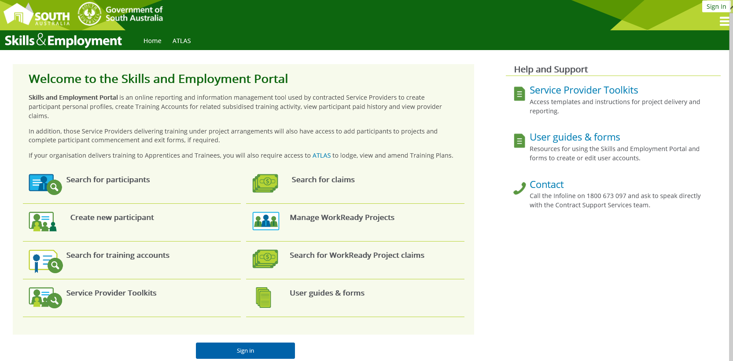

Figure 1 - Screenshot of the Skills and Employment Portal homepage

# Training Account Search

Training Account Search can be done by the Menu Bar. Select ‘**Training Account**’, then ‘**Training Account Search**’ from the sub menu, as shown below:



Figure 2 - Screenshot of the Skills and Employment Portal - Training Account menu

To search for a Participant’s Training Account, you may input **any** of the following, until a match is found, e.g.:

* First Name;
* Last Name;
* Internal unique ID (this should be known by the RTO);
* Participant Number;
* Course Code;
* Course Name.

A Participant may have multiple Training Accounts. Select ‘**View**’ or ‘**Edit**’ to list the full Training Account details of the Participant.

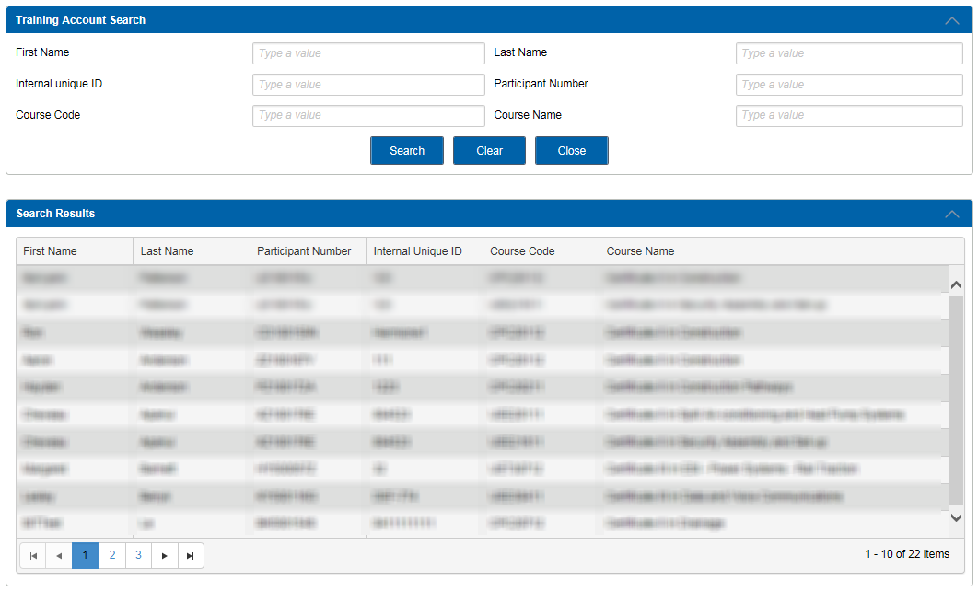

Figure 3 - Screenshot of the Skills and Employment Portal - Training Account Search

* See **Section 8** for How to run a Report on ‘**All Data - Training Accounts Report**’ into Excel.

# Maintaining a Training Account

To ‘**Edit**’ or ’**Update**’ data within a Training Account, the Training Account must be active.

Select ‘**Edit Training Account**’ to update the information in editable fields for that Training Account: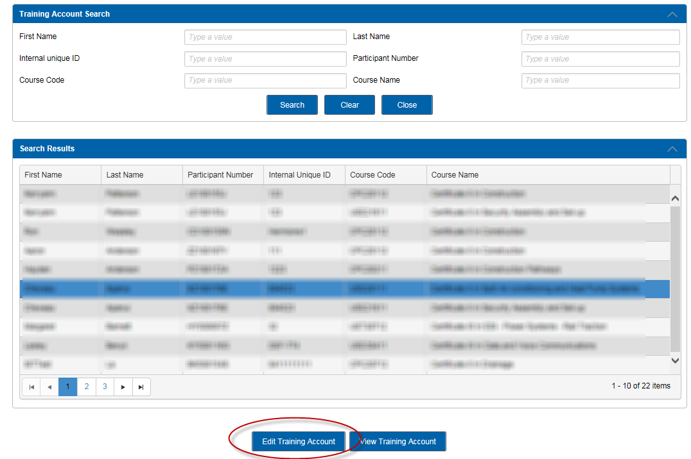

Figure 4 - Screenshot of the Skills and Employment Portal – Edit Training Account

**Editable Training Account Fields for Active Training Accounts**

The following fields are able to be edited for an Active Training Account:

* Commonwealth Government Concession Card type and expiry date
* Estimated Course Fee this Participant will be charged, after any concessions
* Estimated Course Hours for this Participant
* Training Start and End Dates
* Internal unique ID
* Workgroup
* Additional support
* Applied for VET FEE Help
* Delivery Suburb
* Delivery Postcode
* Leave from Enrolment Start and End Dates

# Completion of a Training Account – Issue of a Qualification

When a participant has completed a qualification, Training Providers are requested to record the issue of the qualification in both their own Student Enrolment System (or STELA) and **Portal**.

To update the Training Account with ‘**Qualification Issued**’:

* Follow the ‘**Edit Training Account**’ direction in Section 4;
* Scroll down to the bottom of the Training Account to the Summary Information field;
* From the ‘**Training Account Status**’ drop down box, select ‘**Qualification Issued**’ (as illustrated below), enter the **Parchment Number** and the **Parchment Issued Date**. These fields need to match the parchment details that you have entered in your Student Enrolment System (or STELA).

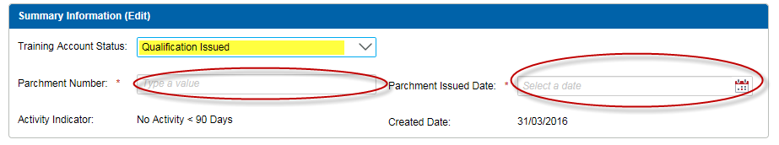

Figure 5 - Screenshot of the Skills and Employment Portal – Edit Training Account - Qualification Issued

Note:

* This process will trigger a Completion Payment, where eligible;
* The date that the parchment details are entered in the Training Account is the Training Account End Date, therefore all training needs to have been completed;
* The Parchment Issued Date is not the Training Account End Date;
* ‘Skill Set’ Training Accounts – to be updated with ‘Qualification Issued’ status once completed. Note that if a Parchment Number is not available, a Statement of Attainment number is acceptable for Skill Set Training Account;
* ‘ESTC’ Training Accounts – refer to **Section 7 - Closing a Training Account**.

# Leave from Enrolment

This status is to accommodate participants who wish to suspend their Training Account and recommence the training at a later date. To enter the ‘**Leave from Enrolment**’ Start and End Dates:

* Follow the ‘**Edit Training Account**’ direction in Section 4;
* Scroll down to the bottom of the Training Account to the Summary Information field;
* Select ‘**Leave from Enrolment**’. The additional fields for Leave Start and End Dates will appear for you to complete.

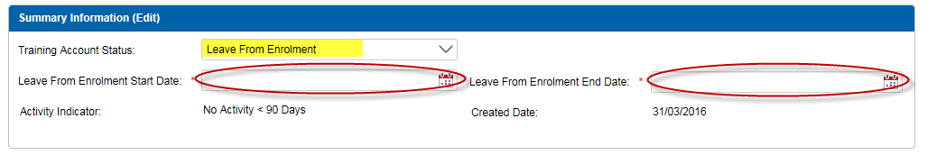

Figure 6 - Screenshot of the Skills and Employment Portal – Edit Training Account – Leave from Enrolment

* See **Section 8** on How to run a Report on ‘**Training Accounts with ‘Leave from Enrolment**’ status’ into Excel. Training Providers are requested to monitor all Training Accounts with ‘**Leave from Enrolment**’ status using this report and ensure to update the Training Account with accurate information.

# Closing a Training Account

Training Providers must maintain Training Accounts accurately and ‘Close’ them when participants do not commence training or withdraw from their course.

The example below shows that this Training Account’s current status is ‘**Active**’ however ‘**No Activity => 90 days**’. This indicates that the Training Account needs to be closed if no activity is envisaged.

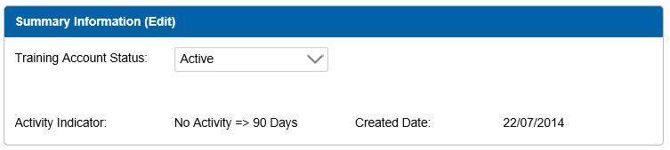

Figure 7 - Screenshot of the Skills and Employment Portal – Edit Training Account - Active No Activity

To close a Training Account:

* Follow the ‘**Edit Training Account**’ direction in Section 4;
* Scroll down to the bottom of the Training Account to the Summary Information field, select the status ‘**Closed**’ and provide a reason for the closure. Examples may include:
* ceased training services; or
* is no longer enrolled in the course.

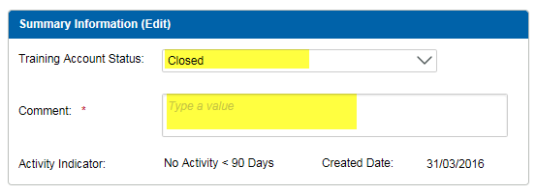

Figure 8 - Screenshot of the Skills and Employment Portal – Closure of a Training Account

**‘ESTC’ Training Accounts** must be ‘**Closed**’ not ‘Qualification Issued’ to avoid eligibility issues for the student.

* See **Section 8** on How to run a Report on ‘**Active Training Accounts with No Activity’** into Excel. Training Providers are requested to monitor all ‘Active Training Accounts with No Activity’ for more than 90 days using this report and close them where required.

# Training Account Reports

The following ‘Training Account’ reports are available for download at any time into Excel to provide an up-to-date summary on:

* All Data - Training Accounts report;
* Active Training Accounts with Concession;
* Active Training Accounts with No Activity*;
* Training Accounts with status ‘Leave from Enrolment’; and
* Training Accounts with Bridging Units.

* Note that the ‘**Active Training Accounts with No Activity**’ report includes all Training Accounts that are Active and have no activity, or had no payments made for more than 90 days, since the Training Account Creation Date or the Last Activity Date, whichever occurs later. This means if you have created a Training Account and expected to commence training more than 90 days after the Training Account creation date, this Training Account will also appear in this report. Expected Training Start and End Dates are included for this purpose.

Data for these reports is refreshed hourly, so if Training Account data is being edited, a new report will be able to be prepared on the same day to confirm the changes.

A search for Training Account Reports can be initiated via the Menu Bar by selecting ‘**Training Account’ - Training Account Reports**’ from the sub menu, as shown below:



*Figure 9 - Screenshot of the Skills and Employment Portal - Training Account Reports menu*

The search screen below will be displayed. Reports are generated by selecting one of the five reports from the drop-down menu option.

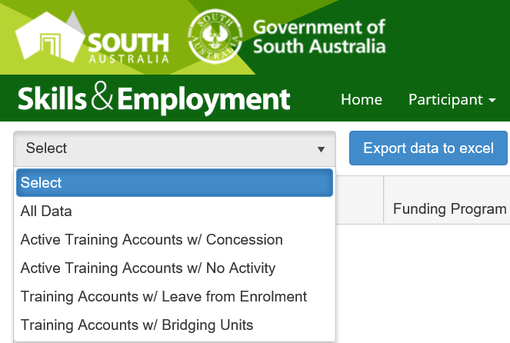

*Figure 10 - Screenshot of the Skills and Employment Portal - Training Account Reports types*

Should the report not contain any data, a message will appear to confirm “**No data is available for export**”

Exporting the data is actioned by selecting the desired report from the drop-down list, then the ‘**Export data to excel**’ button.

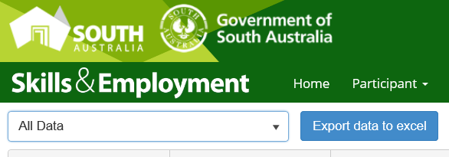

Figure 11 - Screenshot of Skills and Employment Portal - Training Account Report Export function

Once you have selected the button, the system will begin the process of downloading the report:

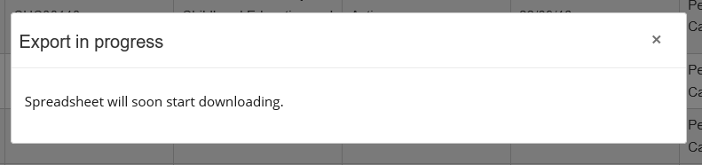

Figure 12 - Screenshot of Skills and Employment Portal - Training Account Report - Export in progress

The system will present you with an option to either open or save the file:



Figure 13 - Screenshot of Skills and Employment Portal - Training Account Report – Open or Save file

If you have selected the open function, the Training Account Report will be exported and opened in Excel as displayed below:

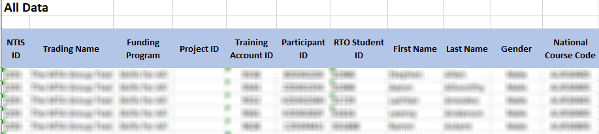

Figure 14 - Screenshot of Skills and Employment Portal - Training Account Report - Export in Excel

# Support and Assistance

If you experience trouble logging into or require any assistance with using the Skills and Employment Portal, please do not hesitate to contact the Contract Administration team.

Your feedback and comments are welcome so that we can continuously improve the **Portal** to meet the needs of our clients.

Telephone: 1800 673 097 and ask for the Contract Administration team

Email: [DIS.SkillsContracts@sa.gov.au](mailto:DIS.SkillsContracts@sa.gov.au)