Skills & Employment Portal
User Guide: Data Collection, View Claims and Payments
(Version 2.3 – Release date: October 2020)
Version | Date | Status | Comments
2.2 | Dec 2019 | Updated | Update Department and the Skills and Employment Portal;  Merged from the ‘Data Collection and Payment Assessment’ and ‘View Claims and Payments’ User Guides
2.3 | Oct 2020 | Updated | Routine Update

Contents
1. Purpose 3
2. Data Collection, Claims and Payments Overview Process 3
3. Enrolment and Training Account 5
3.1 Participant details 5
3.2 Completion of a Training Account – Issue of a Qualification 5
4. AVETMISS data submission 6
4.1 AVETMISS Compliance 6
4.2 Data submission 6
4.2.1. Claim Period 6
4.2.2. Fund Source Identifier 6
4.2.3. AVETMISS data submitted but not processed in Claims and Payments 7
4.2.4. Edit a claim 7
4.2.5. Result Code 70 and Academic Pass (70 and AP) 7
4.2.6. STELA Support and Assistance 8
5. Data accuracy and matching with the Training Account 8
5.1 AVETMISS data: 9
5.2 Skills & Employment Portal - Training Account data accuracy 10
6. View Claims Items and Error Report 10
6.1 Exporting your claim reports from Skills & Employment Portal 11
6.2 Claims with a zero-payment value 14
7. Reconciliation of Accredited Payments to AVETMISS data 15
8. Support and Assistance 15
9. Appendix 1: Fields within claim export file 16
10. Appendix 2: Fields within claim Error Report 17
11. Appendix 3: Validation and Payment Error Codes 18
11.1: Validation rules 18
11.2: Payment Rules 19
11.3: Calculation Rules 21

Purpose
The Skills & Employment Portal (Portal) is an Information Management Portal that provides access to a number of functions including creation of a Participant Profile, Training Account and Claims and Payments. This User Guide assumes that the user has access to the Portal and is intended to assist with the following:
- explanation about linkage between Participant Profile and Training Account data;
- matching data between AVETMISS in STELA and Training Account in the Portal;
- processes for submitting accurate and compliant claims for a subsidy payment; and
- claim errors with meaningful descriptions and suggested action for each error.
As per your current contracting arrangement, Training Providers must ensure:
- a Participant Profile is created (or validated if there is an existing profile), and a Training Account is established for each participant in the Portal;
- all participant data in AVETMISS must match the details contained in the Participant’s Training Account in Portal. Discrepancies between these two data sets will cause errors and prevent AVETMISS data from progressing to the claim for further assessment; and
- no training is delivered prior to creation of a Training Account. All units of competency commenced prior to the Training Account creation date will not be eligible for payment as per the payment rules.
Data accuracy is critical to the successful submission of a claim. Staff managing data entry are strongly encouraged to contact the Contract Administration team for assistance if they are unsure of the required process. This User Guide should be read in conjunction with:
- Your current FAA and relevant STL Qualifications Annexure;
- the South Australian Vocational Education and Training – Training Fee Framework;
- User Guide for Creating a Participant Profile and Training Account; and
- User Guide for Maintaining and Closing Training Accounts;

Data Collection, Claims and Payments Overview Process
The Minister will pay training subsidies to the Training Provider in accordance with the Contract, provided that the Training Provider has submitted data that is complete, compliant and accurate as required by the AVETMISS VET Provider Collection specifications: release 8.0 and that the Training Provider has fulfilled all its obligations under the Contract.
AVETMISS data must be submitted by 5.00pm on the third Tuesday of each month (unless notified otherwise). Data submitted for payment purposes must continue to be submitted for the complete
AVETMISS collection calendar year period. The claims and payments process checks previously paid claim and identifies changes to previous data submissions. The Department utilises this information to work with Training Providers and identify data integrity issues where required. Errors and unresolved data integrity may result in recovery of training subsidies.
Progress of the AVETMISS data submission can be viewed in STELA, and any issues with your AVETMISS data should be directed to the STELA Helpdesk (8226 3050) for assistance. Once the claim has been assessed and completed (expected by the end of every month), student history will be updated with paid history. Claim File and Error Reports will be available in the Portal for download and investigation. Any issues with these reports should be directed to the Contract Administration team.
Successful generation of a claim for payment depends on:
- complete and accurate data in the Training Account for each eligible participant;
- compliant, accurate and complete AVETMISS data submission in STELA; and
- accurate matching of reported data elements against Training Accounts for each participant.
Details of training subsidy including payable result codes, fee calculation and completion payment are illustrated in the Training Fee Framework . Please refer to these documents for details.
Figure 1 shows the three stages of the data process, from data submission to claims and payments.
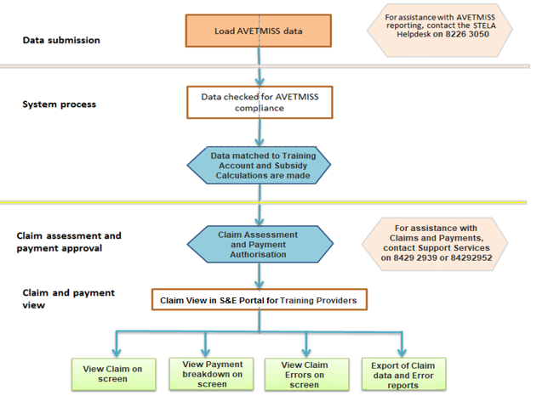
Figure 1 - Three stages of the Data Reporting and Payment Process.

Enrolment and Training Account
On the same day the enrolment contract is agreed with the participant, the Training Provider must create a Participant Profile (or validate an existing profile) and create a Training Account for the participant in the Skills and Employment Portal. This step is crucial, as any training commenced prior to the Training Account creation date will not be eligible for payment. Data accuracy is also crucial as the claim will not transition to the payment system for further assessment if any discrepancies.

Participant details
On creation of Participant Profile and Training Account, the Training Provider must accurately and completely report the following details for each participant in the Portal:
- First Name and Last Name;
- Date of birth;
- Gender;
- Course Code;
- Training Contract ID (where the participant is undertaking the course under an apprenticeship or traineeship) and
- Internal unique ID for Participant (a Training Provider’s internal organisation participant ID). A Training Provider must have one internal participant identification number for each participant and must always use this number for that participant. Note: This is the most important link between your Training Account and reporting your AVETMISS data. This field is mandatory* and is used to match your AVETMISS data to the Training Account. Failing this, the claim will not transition to the payment system for further assessment.
- For Training Providers who use STELA as their enrolment system, the STELA Organisation Participant ID must be used as the “Internal unique ID for Participant” in the Training Account.
In addition, all the remaining fields must be entered accurately in the Training Account, and all information should match with its AVETMISS data.
Training Providers who require an update to a participant’s personal details in the Training Account. To do so, email DIS.skillscontracts@sa.gov.au specifying details that need updating together with any supporting evidence. For further assistance, please contact the Contract Administration team.

Completion of a Training Account – Issue of a Qualification
The Minister may pay a completion payment as per the current contracting arrangement. The payment amount will vary depending on the level of qualification issued. Further information regarding completion payments can be found in the Training Fee Framework.
Prior to making a claim for a completion payment in STELA, the Training Provider must change the status of the participant’s Training Account to “Qualification Issued”, and record parchment information as follows:
- Search for the participant’s Training Account and select ‘Edit’;
- Under Summary Information, find Training Account Status and select “Qualification Issued”;
- Record Parchment Number and Parchment Issued Date;
- Select ‘Save’.
Once saved, the Training Account status will be updated to “Qualification Issued”. No further edits will be possible.

AVETMISS data submission

AVETMISS Compliance
Data must be compliant with the national AVETMISS VET Provider Collection Specification and other relevant AVETMISS standards, otherwise it will not progress to the claim for payment assessment. Each data submission must include the full set of training activity data for that calendar year’s AVETMISS Collection, to that point.

Data submission

Claim Period
AVETMISS compliant data containing payable fund sources are to be submitted to STELA by 5.00pm on the third Tuesday of each month (unless notified otherwise). The data will be used to validate training activity, calculate payment values for each resulted Unit of Competency and generate a claim. Claims are then assessed, authorised and processed for payment within the month.
Once paid, the participant’s subsidised training history is updated, and Training Providers can view their relevant Claim Items and Error Report.

Fund Source Identifier
Training Providers reporting training activity in South Australia via STELA must include the relevant state Fund Source Identifier (FSI). Which FSI to use in STELA will depend on the Funding Program you are contracted to deliver. For each ‘Funding Type / Program Name’ you select when a Training Account is created in the Skills & Employment Portal, there is a matching FSI in STELA.
Training must be reported against one of the following five Fund Source Identifiers in order to be collected for payment review: WRG, ICN*, TGS*, SBA*, EPA.
* Participants who are ICAN, TGSS or Australian School Based Apprentices need to be identified separately for national reporting purposes.

A list of South Australian Fund Source Identifiers and information on how to report funded training activity are available in the WorkReady / Skilling South Australia Fund Sources document.
If you are still unsure which one to use, please refer to your FAA and related Annexure or contact the Contract Administration team for assistance. Training Providers may also ring the STELA helpdesk on 8226 3050 or email DIS.stelahelpdesk@sa.gov.au for clarification of the Fund Types and Fund Sources listed in the above mentioned document.

AVETMISS data submitted but not processed in Claims and Payments
The Claims and Payments process collects all compliant AVETMISS data submitted against payable Fund Sources and matches with data in the Training Account for each eligible participant in the Skills and Employment Portal.
There are a list of Validation and Payment Rules to ensure data imported for Claims Assessment is valid, consistent and accurate, and Training Provider is entitled to receive a subsidy.
Data which does not successfully pass a Validation or Payment Rule will be “systematically declined” and will not be paid. Data which successfully passes all rules will be considered “Pending Assessment” and be ready for further manual assessment to be recommended for payment or decline.
A list of Validation and Payment Rules, including meaningful Error Descriptions and suggested treatments, is available in Appendix 3.

Edit a claim
Once the monthly AVETMISS data is lodged, a claim is created automatically. Assessment of this claim will commence the day after data is lodged, being the 3rd Tuesday of every month (unless notified otherwise). If you find that you have claimed something that is incorrect, you have up to two days to phone and request that the payment be declined immediately, contact the Skills Infoline on 1800 673 097 and ask for Contract Administration. Once a claim has been assessed and approved for payment, it cannot be cancelled or declined.
Errors that have been identified through the claim process can be corrected in your enrolment system where appropriate. Changes will be reflected and processed in the next claim period following your revised AVETMISS data submission. Any data change that modifies a previously paid record to one that is no longer payable, results in ‘significant change’ or ‘missing data’ and may result in recovery of the previously paid subsidy.

Result Code 70 and Academic Pass (70 and AP)
A number of units of competency have been identified as requiring the participant to achieve competency for both off and on-job components (these units are published on the Training Provider website under Result Code 70 and Academic Pass (AP). For these units of competency only, the full subsidy will be paid for the AVETMISS result code 70, accompanied by Academic Pass – AP recorded against the Outcome Identifier Training Organisation in the AVETMISS NAT00120 Enrolment File for the participant, where a participant has successfully completed the off-job component.

Once the Participant has been assessed for both off and on-job components, the Training Provider must convert the 70-AP to a finalised outcome, being:
- 20 (Competency Achieved/Pass) where the competency is achieved;
- 30 (Competency Not Achieved/Fail) where the competency is failed;
- 40 (Withdrawn/Discontinued) where the competency cannot be assessed on-job.
To be AVETMISS compliant, the Training Provider must ensure that all units of competency resulted with 70-AP have an Activity End Date in the following year or are amended prior to the end of the January to December annual collection period to one of the result codes listed above.
“Activity End Date must be after 31 December of the collection period where the Outcome Identifier – national is 70 – Continuing enrolment”
AVETMISS - VET Provider Collection Specifications
Release 7.0 April 2014, page 42
Training Providers who do not use NAT files, but enter their results directly in STELA, can select the Academic Pass result from the drop-down box on the resulting screen. Similarly, these Training Providers should change the result code from Academic Pass to Competency Achieved/Pass, Competency Not Achieved/Fail, or Withdrawn/Discontinued as described above and amend the end date.
Conversion from 70-AP (payable) to a finalised result code 20, 30 or 40 will not generate any further payment for that Unit of Competency.
A qualification must not be issued before all 70-AP result codes are updated with valid AVETMISS result codes.
The Minister may from time to time publish an updated list of units of competency which are eligible for payment for a result code 70-AP. Training Providers should refer to the list published on the website for current information.
Training Providers wishing to add additional units of competency to the 70-AP list may request in writing by email DIS.SkillsContracts@sa.gov.au.

STELA Support and Assistance
For assistance in submitting your AVETMISS data via STELA, please ring the STELA helpdesk on 8226 3050 or email DIS.stelahelpdesk@sa.gov.au.

Data accuracy and matching with the Training Account
AVETMISS data submitted via STELA must be compatible and linked with data in the Training Account for each participant. Unless the claim data matches the Training Account data, it will not proceed to payment assessment. This means that the Training Provider must ensure that the NAT files are accurate when uploading or direct data entry in STELA.
Participant details must be identical in the Training Account and the NAT files.

AVETMISS data:
The Training Provider must ensure that:
- Each AVETMISS data submission must include the full set of training activity data for that calendar year’s AVETMISS Collection, to that point. If the complete set of training activity data both reported and paid in the current AVETMISS Collection calendar year is not part of a Training Provider’s submission, a recovery record is created against the Training Provider exactly equal to the total amount paid previously.
- A correct Fund Source Identifier for the relevant program is selected, as per Section 4.2.2.
- The Activity Start Date for the Unit of Competency must be either on or after the creation date of the Training Account.
- The Activity End Date for the Unit of Competency must be after the date that the Training Account was created and before the end date of the Training Account.
- The Activity Start and End Dates reflect the actual period of training and assessment delivery.
- The Outcome Identifier - national (result code) must be accurate. A subsidy will only be paid based on the AVETMISS Outcome Identifier - national (result code) in accordance with your contracting arrangement and the Training Fee Framework. The Outcome Identifier must only be applied when the participant has completed the Unit of Competency, that is, the final assessment has been undertaken by the participant to complete the requirements for the specific enrolment of the Participant in the Unit of Competency.
- The Delivery Location Identifier must specify the location where the training is delivered. The Training Fee Framework (section 3) clarifies the rules. For classroom and employment-based delivery, the delivery location Identifier is the predominant location where the training is conducted. For electronic and correspondence based delivery, the Delivery Location Identifier must specify the predominant location where the training is coordinated. The Identifier is cross-referenced to the valid suburb and postcode within the NAT00020 file (or registered Delivery Location within STELA for manual entry by Training Providers). Training Providers should review the Training Fee Framework and accompanying postcode list to ensure the correct location is applied.
- Bridging Units - For STELA NAT Upload Training Providers: If claiming for a bridging unit, the NAT00120 file should connect the bridging unit to the Qualification identified in the Training Account.
For STELA manual entry Training Providers: Ensure the bridging units are added to the qualification within STELA and the funding source/type assigned to the units.
- Multiple Failed Attempts – Activity Start and End Dates. If claiming a second or third attempt at a failed Unit of Competency, the Activity Start and End Dates must be different, distinct and not overlap. For each attempt to be funded, Training Providers are required to have evidence (to be made available if requested) that the participant re-enrolled and paid appropriate fees, undertook further training and was re-assessed for a second or third time.

Skills & Employment Portal - Training Account data accuracy
Training Accounts must be accurate and complete. In particular:
- Course Code and the Internal unique ID for Participant must be an absolute match with AVETMISS data, as detailed in Section 3.1;
- Training Accounts must be established before the No New Enrolment date as listed on your contracting arrangement and the Subsidised Training List.
- Commonwealth Government Concession Card type and expiry date – the concession reimbursement will only be paid for a resulted Unit of Competency if the expiry date of the Concession Card is later than the Activity Start Date for the Unit of Competency.

View Claims Items and Error Report
Training Providers can use the Skills & Employment Portal to export Claims Items and Error Reports. This information combined with your STELA Error Report will provide a full overview of errors relating to Claims data. The following instructions will assist you in downloading and viewing Claims Items and Errors Report for your organisation. Once a claim has been assessed and a payment made to Training Providers, data will be available to view and export from the Portal. The status of the claim in the Portal will show as ‘Reconciled’.

Exporting your claim reports from Skills & Employment Portal
- From the Skills & Employment Portal menu, select ‘Claims’, then ‘Claims Search’ as per Figure 2 below:
Figure 2 - Screenshot of Skills and Employment Portal - Claim Search menu

- Your Claim Details screen is then displayed as shown in Figure 3 below
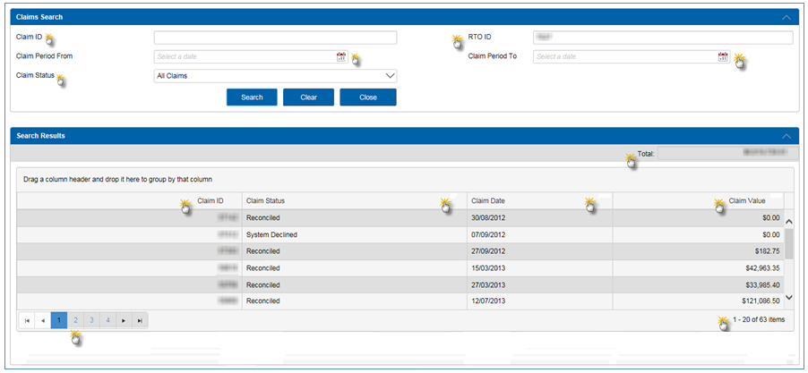
Figure 3 - ’Claims Search’ details on display

Fields in Figure 3 | Explanation
Claim ID | A unique claim number assigned to each new claim. This will automatically populate when you select a particular claim as per Figures 4 and 5.
RTO ID | Training Provider’s Unique ID number as per Training.gov.au
Claim Period From | These fields provide a calendar for easy date selection and entry. However, if these fields are left blank, you will retrieve all claims for your organisation, both current and non-current.
Claim Period To | As above.
Claim Status | Training Providers will now see their claim in the Portal when the status is ‘Reconciled’ or ‘System Declined’. When reconciled, the payment has already occurred.
Search Results Fields
Total | Value displayed is based on search criteria
Claim ID | A unique claim number assigned to each claim, which can be filtered as displayed.
Claim Status | Displays the status of the claim, which can be filtered as displayed.
Claim Date | Displays the date of the claim, which can be filtered as displayed.
Claim Value | Displays the claim value of claims, which can be filtered as displayed.
Page Navigation | Allows the provider to navigate pages to view claims on other pages
Number of Items Retrieved | Displays the number of items retrieved

- Once you have selected the ‘Claim Status’ type and the relevant ‘Claim Period’ click the ‘Search’ button to view details of your claim/s on screen. A sample result is shown in Figure 4 below.

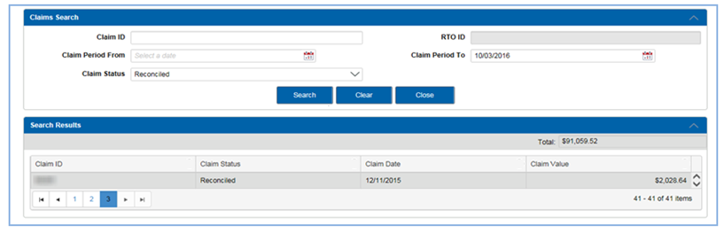
Figure 4 - Sample of Claim Search results
- By double clicking on the row of the selected ‘Claim ID’, you will see a summary of the claim by qualification and the calculated payment values against each qualification as per Figure 5 below. You will also notice that each qualification within the claim is also a linked field.

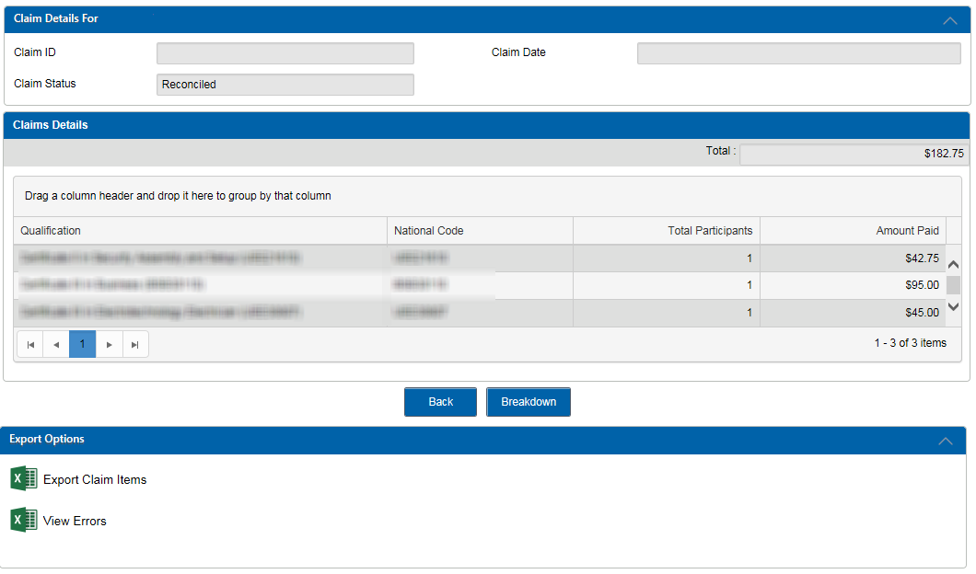
Figure 5 - Summary of the Claim via clicking on the row of the selected ‘Claim ID’
The buttons on the bottom of the screen in Figure 5 are explained below:
Button in Figure 7 | Function
Breakdown | Shows a breakdown on screen of the subsidies and loadings paid.
Back | Takes you back to the previous screen.
Export Claim Items | Generates a report in Excel Format, of all payable items in the claim, including those that have been declined during the payment review process. Appendix 1 of these instructions contains a list of the report fields and descriptions.
View Errors | Generates a report in Excel Format of all Validation and Claim Errors, see Appendix 2 of these instructions for a list of the fields in this report. The report summarises the errors that may exist against your Training Account or against each Claim Line Item by Course, Participant, and Unit of Competency. Appendix 3 of these instructions contains a list of Error Codes and Descriptions. Note: This report does not include claims that have been assessed and declined during the payment review process. These will be in the ‘Claim Items Export’ report.
These export reports will assist to identify any data issues that are able to be corrected before the next claim collection. Remember, when correcting any errors, it is important to make these changes in the administrative system you use to manage your participant and/or your AVETMISS data. Then repeat the data submission process (if necessary) in STELA.

Please also note the following:
- Some errors are old and unable to be fixed. You are recommended to maintain the main register to track all existing errors and add them into the new Error Report each month, to make it easy to identify which errors are new and require attention;
- Within your usual reports, each error is reported for every Unit of Competency included in your AVETMISS data, so once the issue is resolved at the Training Account level, all activities will progress for payment review.

- Double click on a row for a ‘Qualification’ to generate a list of participants in the Claim against that selected course.
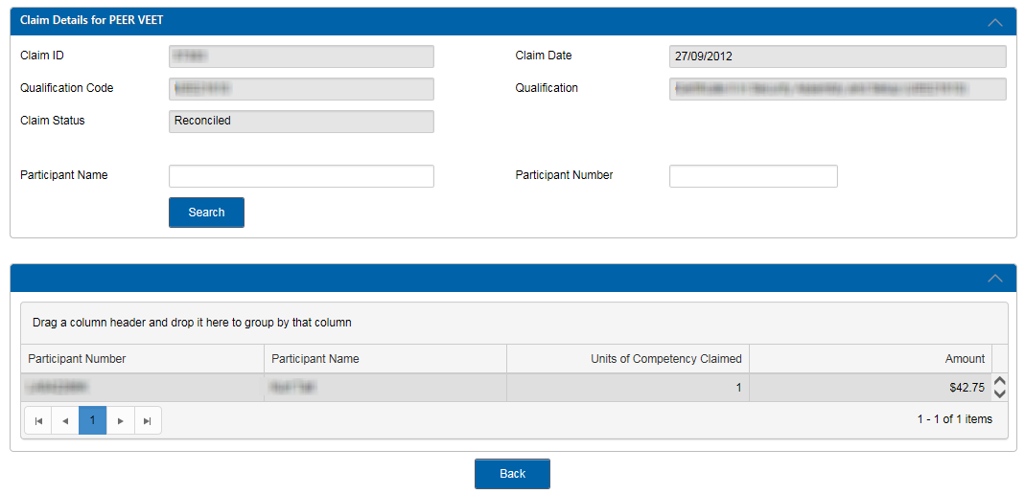
Figure 8 – Qualification drill down view
- You can view or drill down further to the Unit of Competency level and see details of a Unit of Competency and any payment or error code. Double click on a row for a participant to view these details. A further breakdown can be provided (as per bottom section of Figure 9) to provide the payment breakdown details for the highlighted Unit of Competency.
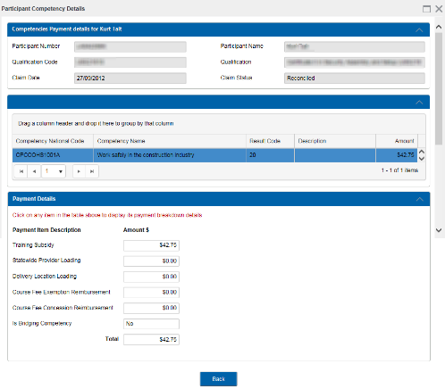
Figure 9 – Participant drill down view

Claims with a zero-payment value
For claims that result in a zero-payment value, it is important that Training Providers export the Skills & Employment Portal Claim Error Report (select ‘Errors’) which will provide a list of errors requiring attention.

All errors resulting in a zero-payment value will be re-assessed in subsequent payment runs. It is therefore important for Training Providers to ensure that all corrections are made in their enrolment systems and that all records including corrected NAT files are uploaded to STELA (for upload Training Providers) or manually entered prior to generating a new claim.

Reconciliation of Accredited Payments to AVETMISS data
Data amendments may occur after the payment has been made. Data amendments where a payable result has been amended to a non-payable result are captured in the Data Reconciliation Report, which identifies discrepancies between paid Accredited data and AVETMISS data that has been subsequently amended since payment occurred.
The reconciliation of Accredited Training Payments to AVETMISS data is undertaken on a monthly basis by the Contract Administration team. Where appropriate, Contract Administration team will follow up with Training Providers directly for either resolution of the issue or confirmation of error and subsequent recovery.
This process is monitored monthly, with more detailed actions undertaken in the later part of the calendar year until after the current calendar year AVETMISS data submission cut-off date in January the following year. This process identifies changes in paid AVETMISS data where:
- The student is missing from STELA;
- The UOC for a student is missing in STELA;
- The fund type has been changed to non-payable fund type (ie from WRG to FFS);
- The result code has been changed to a non-payable result code (ie from a 20 – Competency Achieved to 40-Withdrawn);
- The fund type and the result code have been changed to non-payable.
All recoveries, once verified and confirmed by the Training Provider, will be finalised and invoices will be sent to Training Providers to recover the overpaid amounts on an annual basis.

Support and Assistance
If you experience trouble logging into or require any assistance with using the Skills and Employment Portal, please do not hesitate to contact the Contract Administration team. Your feedback and comments are welcome so that we can continuously improve the Portal to meet the needs of our clients.
Telephone: 1800 673 097 and ask for the Contract Administration team
Email: DIS.SkillsContracts@sa.gov.au

Appendix 1: Fields within claim export file
Export Field | Description
Claim ID | Claim ID assigned to your claim
Claim Date | Date the claim was generated
Training Account ID | Unique System ID linked to Training Account
Claim Line Item ID | Unique transaction key assigned to the Unit of Competency in the claim
NTIS ID | Unique National ID assigned to the Training Provider as per Training.gov.au
Trading Name | Training Provider Trading Name
Participant ID | Participant ID
RTO Student ID | Training Provider’s unique Student Identifier
TCID | Training Contract ID (for Apprentices or Trainees) stored in the Participant Training Account
Participant Surname | Participant Surname
Participant First Name | Participant First Name
Participant Other Name | Additional names assigned to the participant
Date of Birth | Participant Date of Birth
National Course Code | National qualification code assigned to the qualification undertaken by the participant
Course Name | Qualification Description
Competency Code | National code assigned to the Unit of Competency undertaken by the participant
Training Start Date | The reported training start date of the Unit of Competency
Training End Date | The reported training end date of the Unit of Competency
AVETMISS Result Code | AVETMISS Unit of Competency Result code
Field of Education | Identifies the area of learning pertaining to the course
Payment Type | Competency or Qualification
Transaction Type | Payment (only Transaction Type currently)
Claim Line Item Status | Status assigned to the Claim Line Item  (System Declined, Approved, Reconciled or Declined)
Amount to Pay | Total amount payable
Error Code | Error code identifier assigned to the claim line item
Error Description | Description of the error against the claim line item  (See Appendix 3 for more information and suggested treatments)
Assessment Outcomes | Manually assessed outcome
Work Group | Used by the Training Provider to identify workgroup responsible for participant delivery and assessment
Concession | Eligible concession reimbursement
Training Subsidy | Subsidy Paid
State Wide Provider Loading | Loading paid for state wide delivered training
Delivery Location Loading | Loading paid for training delivered in a remote location
Course Fee Exemption | Eligible exemption reimbursement
Qualification Completion Payment | Eligible completion payment

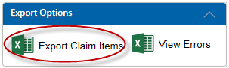

Appendix 2: Fields within claim Error Report
Export Field | Description
Contract Expires | Date your contract expires
Claim Date | Date the claim was generated
NTIS ID | Unique National ID assigned to the Training Provider
Training Account ID | Unique System ID linked to Training Account
Training Account Status | Status assigned to the Training Account: Active with Activity, Active with no Activity, leave from Enrolment, Qualification Issued, Terminated Agreement
Participant ID | Participant ID
RTO Student ID | Training Provider’s unique Student Identifier
Participant Surname | Participant Surname
Participant First Name | Participant First Name
Participant Other Name | Additional names assigned to the Participant
Date of Birth | Participant Date of Birth
National Course Code | National code assigned to the qualification undertaken by the Participant
Course Name | Qualification Description
Competency Code | National code assigned to the Unit of Competency undertaken by the Participant
Training Start Date | The reported training start date of the Unit of Competency
Training end Date | The reported training end date of the Unit of Competency
AVETMISS Result Code | AVETMISS Unit of Competency Result code
Provider Result Code | Training Provider Unit of Competency Result code
Delivery Location Post Code | Delivery Location Post Code
Delivery Location Suburb | Delivery Location Suburb
Qualification Issued Flag | Flag used to indicate if the qualification has been issued
Error Code | Error code identifier assigned to the claim line item
Error Description | Description of the error against the claim line item  (See Appendix 3 for more information and suggested treatments)
Location Classification | Classification applied to the delivery location
Location Loading | Loading paid for training delivered in a remote location
Provider Participant Fee | Participant fee as indicated in the Training Account
Provider Participant Hours | Participant delivery hours as indicated in the Training Account
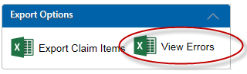

Appendix 3: Validation and Payment Error Codes

11.1: Validation rules
The Validation Rules are used to ensure data imported into the Claims and Payment Assessment process is valid, consistent and accurate prior to being processed.
Payment  Rule ID | Error Description | What this Means | Suggested Treatment
1001 | Duplicate record | Two identical records have been reported in a Providers AVETMISS Submission | Review data to ensure no duplicate records are submitted in your AVETMISS data.
1002 | Conflict record | Two records have been reported in a Providers AVETMISS Submission which counter act one another | Review data to ensure no conflicting UOC records with overlapping dates for the same Participant, are submitted in your AVETMISS data.
1004 | Qualification Not Found | Unable to locate an approved Qualification for the Providers AVETMISS Submission | Review your AVETMISS data for this Course / Qualification against your approved Schedule of Courses.
1006 | Competency Not found | Unable to locate an approved Unit for the Providers AVETMISS Submission | Review your AVETMISS data for this Unit of Competency. This Unit of Competency Code is not eligible against this Course / Qualification.
1007 | Location not found | Unable to locate a matching Suburb AND Postcode for the “Delivery Location” information within a Providers AVETMISS Submission | Review the combination of suburb and postcode used for the delivery location. Combination in AVETMISS data is not valid.
1008 | Training Account not found | Unable to locate a matching Training Account against information within a Providers AVETMISS Submission | AVETMISS data must match the Training Account. Check that the Student RTO ID and Course / Qualification code in your AVETMISS data matches the information against the Participant Training Account.
1009 | Participant not found | Unable to locate a matching Training Account for the Participant in the Providers AVETMISS Submission | AVETMISS data must match the Training Account. Check that the Student RTO ID and Course / Qualification code in your AVETMISS data matches the information against the Participant Training Account.
1010 | Qualification code missing | AVETMISS Submission does not include a “Qualification Code” | Review your AVETMISS data for this Course / Qualification. The Course / Qualification code is missing.
1012 | Internal unique ID missing | AVETMISS Submission does not include a “internal unique ID” | Review your AVETMISS data for this participant. Internal unique ID is missing.
1013 | Competency code missing | AVETMISS Submission does not include a Unit of Competency Code | Review your AVETMISS data for this Unit of Competency. Unit of Competency Code is missing or incorrect in your submission.
1014 | Training Start Date missing | AVETMISS Submission does not include the required “Training Start Date” for this record | Review your Unit of Competency’s training start date in your AVETMISS Data.
1015 | Training Finish Date missing | AVETMISS Submission does not include the required “Training Finish Date” for this record | Review your Unit of Competency’s training end date in your AVETMISS Data.
1017 | Participant Date of Birth missing | AVETMISS Submission does not include a “Date of Birth” for this participant | Review your AVETMISS data for this Participant. Participant Date of Birth is missing.
1019 | Location Suburb missing | AVETMISS Submission does not include the required “Delivery Location Suburb” for this record | Review your AVETMISS data for this Participant. Delivery Location Suburb is missing.
1020 | Location Postcode missing | AVETMISS Submission does not include the required “Delivery Location Postcode” for this record | Review your AVETMISS data for this Participant. Delivery Location Postcode is missing.
1021 | Organisation does not have an active contract | Provider does not have an active Contract

11.2: Payment Rules
The Payment Rules are used to validate whether a Training Provider is entitled to receive a payment for a completed Qualification or Unit of Competency as per the current contracting requirements.
Payment  Rule ID | Error Description | What this Means | Suggested Treatment
PR210B | Qualification completion payment cannot be paid unless the Training Account status is set to Qualification Issued. | The Training Account for this Participant has not been updated to reflect that the Qualification is complete. | Update the status of the Training Account to 'Qualification Issued';  Record the Parchment Number and issued date; and  The Course / Qualification meets WorkReady Completion payment criteria.
PR1000A | Maximum number of Units of Competency required for this Qualification has been funded | Maximum number of units of competency for this course has been subsidised. | This information is viewable in the Participant funded training history in Portal.
PR1000B | Maximum number of Bridging Units have been funded | The maximum number of bridging units for this Participant has been subsidised. | This information is viewable in the Participant funded training history in Portal.
PR1020A | Unit start date is prior to contract start date | Provider is reporting units that commenced before their contract was executed | Any training activity that commenced prior to the execution of your Contract is not eligible for subsides.
PR1020B | Unit start date is after Training Account end date | Provider is reporting units with a training start date after the End Date of the Training Account | Any training activity that is completed before the date the Participants Training Account is created is not eligible for subsidies.
 | Training Accounts created on or After 1/3/2016:  Unit end date is after the Training Account end date | Provider is reporting units with training end date after the Training Account end date | Any training activity that ends after the date the Participants Training Account is terminated or qualification issued is not eligible for subsidies.
PR1020C | Unit end date is before the Training Account create date | Provider is reporting units with training end date before the Training Account create date | Any training activity that commenced after the end date of the Participants Training Account is not eligible for subsidies.
 | Training Accounts created on or After 1/3/2016  Unit start date is before the Training Account create date | The unit start date must be on or after the Training Account create date | Any training activity that commenced before the creation date of the Participants Training Account is not eligible for subsidies.
PR1030A | Participant has already passed this Unit | This Unit of Competency has already been subsidised | The Unit of Competency for this Participant has already been subsidised. This information is viewable in the Participants subsidised training history in Portal.
PR1030B | Participant has exceeded 3 paid attempts in this Unit | This Unit of Competency has exceeded maximum subsidised attempts | The maximum number of attempts for this Unit of Competency, for this Participant has been subsidised. This information is viewable in the Participants subsidised training history in Portal.
PR1040 | Course completion payment has already been issued for this Course | A completion payment for this course has already been subsidised | The Course completion payment for this Participant has already been subsidised. This information is viewable in the Participants subsidised training history in Portal.
PR1050A | AVETMISS Qualification issued date is in the future or null | The Qualification issue date is in the future or missing. | Review your Qualification issue date in your AVETMISS data for this Participant.
PR1050B | Qualification issued date is null or before the Training Account created date | The Qualification issue date is missing or prior to the creation date of the Training Account. | Review your Qualification issue date in your AVETMISS data for this Participant.
PR1080 | Unit start date is prior to 2/7/2012 | Provider is reporting units/courses under the Skills for All funding source before Skills for All was available | Training activity that commenced prior to the commencement of Skills for All is not eligible to be subsidised.
PR1100 | Result code is for RPL and course is a Skill Set | Provider is reporting RPL outcome for a Skill Set. | WorkReady does not subsidise outcomes of RPL for Skill Sets.
PR1110 | Unit reported is not part of the identified skill set | Provider is reporting units of competency which are not part of the agreed Skill Set | Review your AVETMISS data for this participant. The Unit of Competency you are reporting is not a valid unit for this Skill Set.
PR1120 | RPL is not payable for this course | Provider is reporting RPL for a unit under a course where RPL is not subsidised | WorkReady does not subsidise outcomes of RPL for this Course. This payment rule is for a notification only rule, this information is viewable in the Participants subsidised training history in Portal.
PR1128 | Completion payment can only be claimed/paid against Courses where no units have a 70AP result code | Provider is reporting a completion for a Qualification which still has units recorded as 70AP | Review AVETMISS data for this Participant. There are AP70 Result Codes in the participant’s training history in Portal.
PR1130 | Unit End Date must not be after Contract Completion Date | Provider is reporting a unit where the training end date is after the providers no new Enrolment Date. | Review AVETMISS data for this Participant. There are results that ended after your Contract Training End Date.
PR1131 | Provider contract has expired or been terminated | Provider is reporting after their Contract has expired or has been terminated
PR1140 | Qualification issued date cannot be after the contract expiry date | Provider is reporting Qualification Completion after their Contract Expiry Date | The Course / Qualification issue date is after the Contract expiry date. Review your Qualification issue date in your AVETMISS data for this Participant.
PR1170 | No Payment on 70AP for this Course | Provider is reporting a 70AP result code for a Unit of Competency which is ineligible for 70AP use | WorkReady does not subsidise outcomes of 70AP for this Unit of Competency.
PR1190 | Unit attempts overlap, this unit start date is within a previous unit attempt start and end date range | A Provider is reporting an attempt for a Unit of Competency where both previous unit and the new unit start dates overlap | Review AVETMISS data for this Participant. Additional attempts at a Unit of Competency must have a commencement date which is after the completion date of the Participants prior attempt.

11.3: Calculation Rules
The Calculation Rules are used to validate the payment value for a Unit of Competency or Completion Payment as per the current contracting arrangement.
Payment  Rule ID | Error Description | What this Means | Suggested Treatment
SC601010 | RTO Participant fee value is invalid. | The Training Account for this Participant has a Participant fee entered that is invalid. | Review the Training Account for this Participant.
SC601011 | RTO Participant hours value is invalid | The Training Account for this Participant has Participant hours entered that are invalid. | Review the Training Account for this Participant.

