**Skills & Employment Portal**

User Guide: Creating a Participant Profile and Training Account

Version 5.1 – Release date: October 2020

|  |  |  |  |
| --- | --- | --- | --- |
| **Version** | **Date** | **Status** | **Comments** |
| 5.0 | August 2019 | Updated | Update DIS and the Skills and Employment Portal |
| 5.1 | October 2020 | Updated | Update Concession details and Course Fees fields |

**Table of Contents**

1. Purpose 3

2. System login 3

3. Participant Search overview 3

4. Allocate a Participant Number 3

5. View Participant History 4

6. Create a Participant Profile 5

7. Create a Training Account 7

7.1. Participant Details 7

7.2. Training Account Details 8

7.2.1. Funding Type / Program Name 8

7.2.2. Select a Course 8

7.2.3. Residency and Visa Details 9

7.2.4. Employment Service Provider Status 9

7.2.5. School Status 9

7.2.6. TGSS Status 10

7.2.7. Concession Details 10

7.2.8. Other Concession Details 10

7.2.9. Employment Details 11

7.2.10. Has Completed SACE or Equivalent 11

7.2.11. Education Details 11

7.2.12. Training Contract Details 11

7.3. Bridging Units 12

7.4. Course Fees and Training Information 13

7.4.1. Course Fees 13

7.4.2. Training Information 13

7.5. Complete the Creation of a Training Account 14

8. Training Account Search 14

9. Appendix 1 - Editable Training Account Fields 15

10. Support and Assistance 16

# Purpose

The Skills & Employment Portal (**Portal**) is an Information Management Portal that provides access to a number of functions including creation of a Participant Profile, Training Account and view Claims and Payments. This User Guide is intended for staff of a Training Provider who have access to the Portal and are entering or managing Participants and Training Accounts information.

As per the current contracting requirements (clause 19, Attachment 2 of the Funded Activities Agreement (**FAA**)), Training Providers must ensure the accuracy and currency of Participants and Training Accounts information in the Portal.

For Training Providers delivering Accredited Training under an Attachment 4 of the FAA through a Skilling South Australia (SSA) Project, please refer to the [SSA Project – Skills & Employment Portal Reporting Instructions](https://providers.skills.sa.gov.au/Resources/Provider-toolkits/Skilling-South-Australia-Projects).

This document should be read in conjunction with the following documents:

* your current FAA and relevant STL Qualifications Annexure; and
* the South Australian Vocational Education and Training – [Training Fee Framework](https://providers.skills.sa.gov.au/Deliver/Training-Fee-Framework).

# System login

The **Portal** operates in a secure environment, and you will need a Username and Password to log into the Portal. If you do not have a login, please complete the [User Maintenance Form](https://s.skills.sa.gov.au/Training-providers/Contracted-service-provider-resources/Access-our-systems/Help-with-using-the-Skills-and-Employment-Portal) on our website.

On receipt of your Username and Password, use the following steps to access the Portal:

1. Open your web browser. Please note that **Internet Explorer** is our preferred internet platform;
2. Type the following web address [https://Portal.statedevelopment.sa.gov.au/workready](https://portal.statedevelopment.sa.gov.au/workready)
3. Select the ‘**Sign in**’ button in the **top right-hand** corner on the displayed Portal screen;
4. Enter your Username (your email address) and Password;
5. Click on the ‘**Sign In**’ button.

If you require assistance with your access to the Portal, please refer to the [User Guide: Portal Login Procedures](https://portal.statedevelopment.sa.gov.au/WorkReady/polices_forms2).

# Participant Search overview

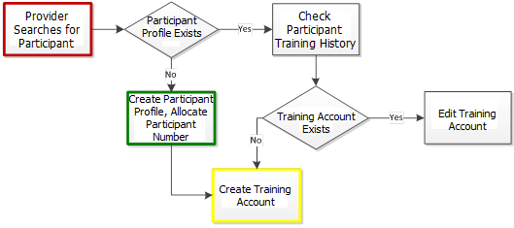

Figure 1 - Workflow of Skills and Employment Portal search

# Allocate a Participant Number

The Participant number is a unique number generated by the Portal and is required for a Participant to access Government subsidised training*.* It is only allocated once and is used to record the delivery of Accredited Training. It may also be used to determine future eligibility for subsidised courses.

**Note:** The first step before allocating a Participant number is to search in the Portal to ensure that there is not an existing Participant Profile for the Participant.

From the Portal Menu Bar, select ‘**Participant**’ ***>*** ‘**Participant Search**’from the sub-menu, as shown below:

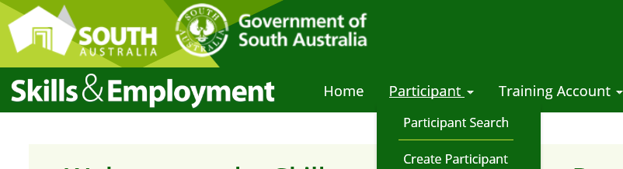

Figure 2 - Screenshot of Skills and Employment Portal - Participant menu

1. You may search an existing Participant Profile in the Portal by entering either:

* a combination of Participant details: First Name, Last Name and Date of Birth; or
* a Participant Number – this is a unique number generated by the Portal for a participant who has an existing profile and is only allocated once.

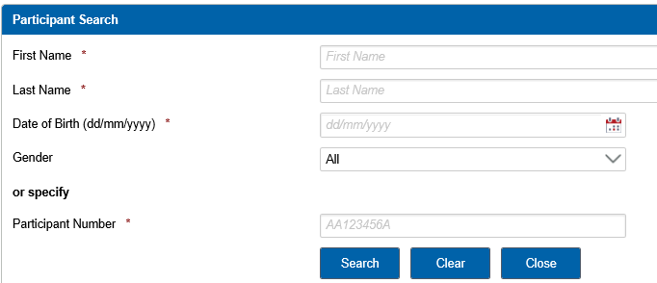

Figure 3 - Screenshot of Skills and Employment Portal - Participant Search

1. If there is a match, the Participant record will appear as displayed below. If more than one Participant Profile is found, the Portal will prompt for more information about the Participant, in order to match with other fields in the Participant Profile.

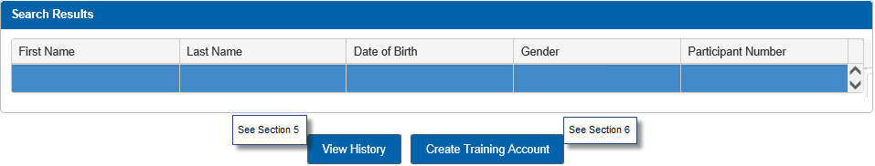

Figure 4 - Screenshot of Skills and Employment Portal - Search results

**Note**: Once you have retrieved a Participant in the Portal, you should check the Participant’s history to ensure the Participant is eligible. To do this, simply click the ‘View History’ button.

If the Skills & Employment Portal is unable to retrieve matching data, a message will be displayed stating no Participant Profile could be found. You can proceed to Section 6 - Create a Participant Profile.

# View Participant History

The Participant History Screen provides further information on Training Account(s) created against a participant. These Training Accounts may or may not impact on the participant’s entitlement, as explained below.

Training Accounts which show under the ‘**Subsidised Training History**’ section **may** impact on entitlement, include:

* Training Accounts that are defined as ‘**Active**’ (i.e. those that have a status of ‘Active No Activity’, ‘Active with Activity’ or ‘Leave from Enrolment’); **or**
* Training Accounts that have a ‘**Qualification Issued**’ status and the Training Account End Date is after 01/10/2015.

Training Accounts which show under the ‘**Subsidised Training History (no impact on Entitlement)**’ section which do not impact on entitlement include:

* Training Accounts that have a ‘Qualification Issued’ status and the Training Account End Date is prior to the 01/10/2015; or
* Training Accounts that have a ‘**Closed**’ status.

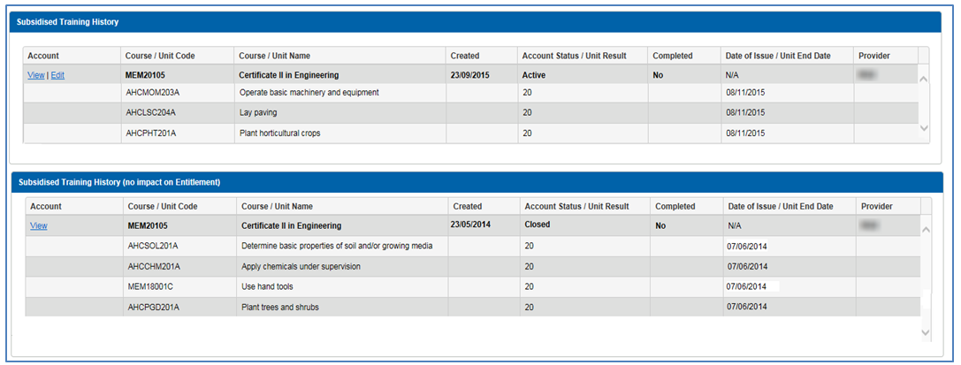

Figure 5 - Screenshot of Skills and Employment Portal - Subsidised Training History

From the above display, you are able to see the date when Training Accounts were created, status of the Training Accounts and the date of ‘**Qualification Issued**’ (if any). For Training Accounts where you are the Training Provider, an option to view further details will appear under the ‘**Account**’ column. Click **‘View**’ to ‘**Open/Edit**’ the Training Account.

Note that as soon as a Training Account is created, the course information will show on the Participant History, even before any units have been claimed.

# Create a Participant Profile

Participant Profiles should only be created if one does not already exist for that participant. Before creating a Participant Profile, you must first search the Portal to check if a Profile already exists to avoid creation of duplicate records.

Creation of a Participant Profile can be actioned via the Menu Bar by selecting **Participant *>* Create Participant** from the sub-menu as shown below, by using information you have gathered on your Enrolment Form.



Figure 6 - Screenshot of Skills and Employment Portal - Participant Menu

Refer to the table below for information to be entered into the Portal. Mandatory fields are indicated by an asterisk (*). **Please check information entered for accuracy before completing the Participant Profile and ensure information is consistent with any training reported in STELA for that participant.**

|  |  |  |
| --- | --- | --- |
| **Field** | **Format** | **Additional Information** |
| **Participant Details** | | |
| First Name * | Free text | This field is mandatory. Use capitals for first letter of each name, unless this is not a required in the spelling of the name. |
| Preferred First Name | Free text | Use capitals for first letter of each name, unless this is not a required in the spelling of the name. |
| Middle Name | Free text | Used to search if there is more than one match in the Participant Profile.  Use capitals for first letter of each name, unless this is not a required in the spelling of the name. |
| Last Name * | Free text | This field is mandatory. Use capitals for the first letter of the last name, unless this is not required in the spelling of the name. |
| Gender * | Drop down selection | This field is mandatory. Options are: Male, Female, or Not specified |
| Date of Birth * | Number only | This field is mandatory. Date format – DD/MM/YYYY |
| **Residential Address Details** | | |
| Address Line 1 | Free Text | Unit, Road, Street, Avenue etc. |
| Address Line 2 | Free Text | Unit, Road, Street, Avenue etc. |
| Postcode * | Number only | This field is mandatory. Example: 5000 |
| Suburb * | Drop down selection | This field is mandatory. Suburb options will display upon entry of a valid postcode. Select the appropriate suburb name. |
| **Contact Details** | | |
| Email * | Free Text | Must provide at least an email address OR mobile phone number.  Example: [email@address.com.au](mailto:email@address.com.au) |
| Mobile Phone Number * | Number only | Must provide at least an email address OR mobile phone number.  Please do not use spaces. Example: 0444144144 |
| Home Phone Number | Number only | Please do not use spaces. Example: 0818881888 |
| Work Phone Number | Number only | Please do not use spaces. Example: 0818881888 |
| **Participant Agreement** | | |
| Participant consent has been gained * | Check box | This field is mandatory. Checking this box is an indication that the Participant has completed and signed a Participant Agreement form for collection and use of their personal information*. |

* Note that the **Participant Agreement** form sets out the purpose for which personal information is collected by the Minister for Innovation and Skills and how it will be used. This is only completed by the Participant once for each Training Provider. The FAA requires Training Providers to enter into a Participant Agreement with each participant. Training Providers are not required to email a copy of the completed Participant Agreement form to the Department however they must retain the signed form.

Complete the process to create a Participant Profile by selecting ‘**Create Participant**’. Note that once the Participant Profile has been created, you are unable to amend any of its details. Any amendments to the Participant Profile should be **notified in writing** by email to [DIS.SkillsContracts@sa.gov.au](mailto:DIS.SkillsContracts@sa.gov.au) together with supporting evidence.

Creation of a Training Account can be proceeded directly from this screen by selecting the ‘**Create Training Account**’, as below:

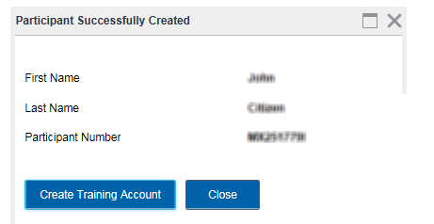

Figure 7 - Screenshot of Skills and Employment Portal - Participant Successfully Created

# Create a Training Account

Please note that creation of a Participant Profile and a Training Account are inextricably linked and should be undertaken on the same day. The Minister’s liability to pay the subsidy will only be triggered if a Participant Profile and Training Account are created in the Skills and Employment Portal. If you experience any trouble in creating a Participant Profile or Training Account, please contact the Contract Administration team for assistance.

To create a Training Account for an established Participant Profile, you must first complete a ‘Participant Search’, as details in **Section 4** above.



Figure 8 - Screenshot of Skills and Employment Portal - Participant Menu

Enter the Participant Details or Participant Number and select ‘**Search**’. If a Participant Profile has been established, the Participants Profile will be displayed as below:

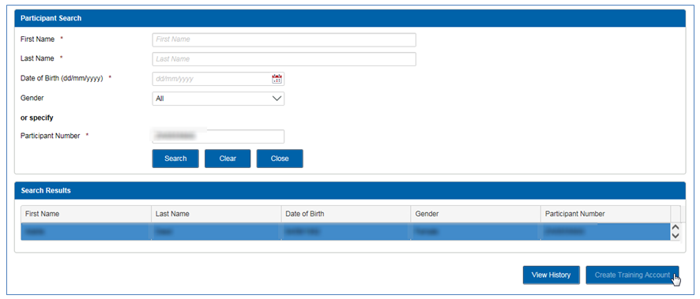

Figure 9 - Screenshot of Skills and Employment Portal - Participant Search

**Note**: Prior to creating a Training Account, you must:

* check the Participant History to confirm entitlement;
* check to see that the Participant Profile data matches the participant’s enrolment, and then select the ‘**Create Training Account**’ button to create a Training Account for the selected Participant;
* ensure to enter correct details when creating a Training Account, as data inaccuracy may impact on payment.

## Participant Details

On clicking the ‘**Create Training Account**’ button, the following screen will appear:

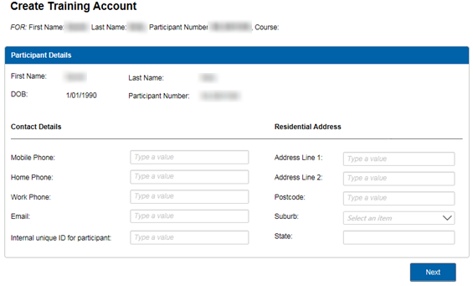

Figure 10 - Screenshot of Skills and Employment Portal - Participant Details

**Internal unique ID:** Often referred to as **RTO Student ID**, this is the most important **link** between your Training Account and AVETMISS data. This number is assigned to the Participant, either from your Student Management Software or if you use STELA as an enrolment system, the State Student ID Number from STELA.

This field is mandatory and is used to match your AVETMISS data to the Training Account. Failing this, the claim will not transition to the payment system for further assessment.

**Note**: If you are not the Training Provider who originally created the Participant Profile, you will be required to enter in the Training Account the residential address and contact details of the participant.

## Training Account Details

### Funding Type / Program Name

This is a drop-down selection. A correct Program Name must be selected as this determines which courses will be displayed for selection in the next step. The Program Name should be indicated on the relevant contracting documentation (Attachment 2, 3 or 4 of your FAA), or if unsure, please contact the Contract Administration team for assistance.

|  |  |
| --- | --- |
|  |  |

*Figure 11 - Screenshot of Skills and Employment Portal – Select Program Name*

### Select a Course

A selection of Courses will be displayed if they are available on your contracted scope for the ‘Program Name’ that was selected in the previous step.

Click **Select a Course,** then enter either the National Code or Course Name, double click on the National Code / Course Name to add to the Training Account.

|  |  |
| --- | --- |
|  |  |

*Figure 12 - Screenshot of Skills and Employment Portal - Select a Course*

### Residency and Visa Details

Select the relevant Residency Type. If the Participant’s Residency Type is a ‘**Holder of eligible visa**’, a Visa Category Name (subclass) must be selected.

If a Visa Subclass is not listed, a Training Provider may apply for an exemption to the eligibility criteria. Complete a ‘[Special circumstances exemption form](https://providers.skills.sa.gov.au/Resources/Forms-and-publications/Subsidised-training)’ and email to [DIS.SkillsContracts@sa.gov.au](mailto:DIS.SkillsContracts@sa.gov.au) for consideration. All applications are assessed on a case by case basis.

|  |  |
| --- | --- |
|  |  |

Figure 13 - Screenshot of Skills and Employment Portal - Residency and Visa Details

### Employment Service Provider Status

Select ‘Yes’ or ‘No’ depending on whether the Participant is registered with an Employment Service Provider. If ‘Yes’ is selected, it is compulsory to enter the Employment Service Provider and the Participants Job Seeker ID Number.

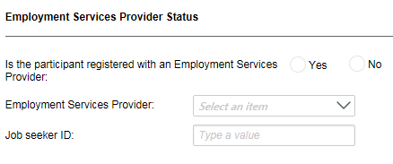

Figure 14 - Screenshot of Skills and Employment Portal - Employment Service Provider Status

### School Status

Select ‘Yes’ or ‘No’ depending on whether the Participant is enrolled at school:

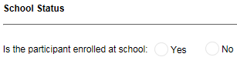

Figure 15 - Screenshot of Skills and Employment Portal - School Status

### TGSS Status

Select ‘Yes’ or ‘No’ depending on whether the Participant is a Training Guarantee for SACE Student:

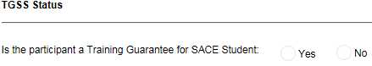

Figure 16 - Screenshot of Skills and Employment Portal - Training Guarantee for SACE student

### Concession Details

Select the relevant ‘**Commonwealth Government** **Concession Card**’ type where applicable. Note that if the Training Account is active, Commonwealth Government concession card details can be updated using the ‘**Edit Training Account**’ function at any time.

Training Providers must maintain the Concession Expiry Date in the Portal or it may impact the concession reimbursement. An ‘Active Training Accounts with Concession’ report is available to assist Training Providers to manage Participant’s concession details. The Concession Expiry Date must be valid at the commencement of training in a Unit of Competency for concession entitlement.

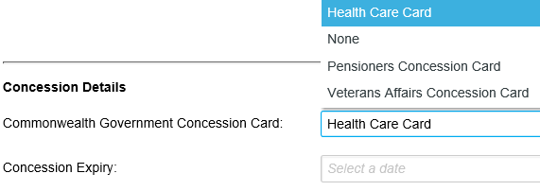

Figure 17 - Screenshot of Skills and Employment Portal - Concession Details

### Other Concession Details

Select ‘Yes’ on ‘**Other Concession Details’** where:

* The participant is not employed; or
* The participant is aged 16 to 24 years old and not enrolled in a secondary school; or
* the participant is a prisoner in a South Australian correctional institution.

To view current Concession Eligibility Criteria, please refer to the [Training Fee Framework](https://providers.skills.sa.gov.au/Deliver/Training-Fee-Framework). By selecting ‘Yes’ to this field, you confirm that you have checked and obtained the evidence to ensure that the participant is eligible for Other Concession.

**Note:** The concession expiry date is not required under this section.

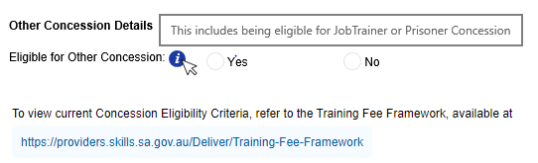

Figure 18 - Screenshot of Skills and Employment Portal - Other Concession Details

### Employment Details

Select ‘Yes’ or ‘No’ depending on whether the Participant is employed or not. Further details of ‘Place of Work Address’ are required if an ‘Yes’ is selected.

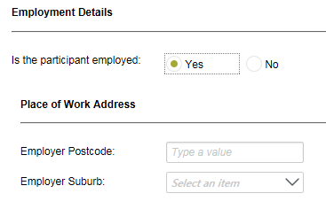

Figure 19 - Screenshot of Skills and Employment Portal - Employment Details

### Has Completed SACE or Equivalent

Select ‘Yes’ or ‘No’ depending on whether the Participant has completed SACE/Year 12 or equivalent.

**Note:** This information is essential to assess eligibility and course entitlement against the new criteria and should be collected for all Participants. Collection of a Participant’s highest level of schooling is also mandatory data for AVETMISS reporting.

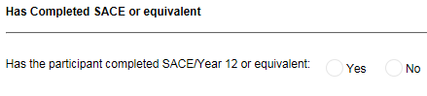

Figure 20 - Screenshot of Skills and Employment Portal – Completion of SACE or equivalent

### Education Details

Select the ‘Highest level of education’ the Participant has previously achieved in Australia.

**Note:** Only AQTF Recognised and higher Educational Recognised Qualifications should be listed in this section. Overseas Qualifications are not recognised in Australia and should not be listed.

|  |  |
| --- | --- |
|  |  |

Figure 21 - Screenshot of Skills and Employment Portal - Education Details

### Training Contract Details

Select if the Participant has an approved Training Contract. Note that if the Course Condition is ‘Training Contract Only’, this section must be completed and the Training Contract number be entered accurately for payment assessment. If a Training Account is created and the valid Training Contract number is not provided, Training Provider accepts the risk that no subsidies will be paid.

Select if the Training Contract is a School Based Training Contract and enter the Training Contract number. The number must be accurate in this format: – eg. 123456\1.

**Note:** If the Participant is approved as FLO or Skilled Migrant, please select ‘Approved Training Contract – YES’, then:

* for FLO participant: select ‘School Based – YES’ and enter the FLO exemption number; or
* for Skilled Migrant: enter the Exemption Number in the ‘Training Contract Number’ field.

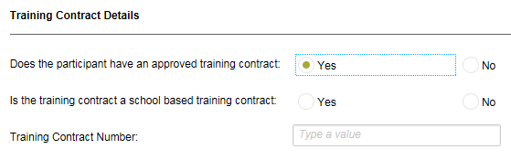

Figure 22 - Screenshot of Skills and Employment Portal - Training Contract details

## Bridging Units

Once the desired Course Code has been selected, you may select up to five Bridging Units to be attached to the course.

Select ‘**Add Bridging Unit**’ to continue or ‘**Next**’ to skip adding bridging units.

**Note:** An eligible participant is entitled to undertake up to five bridging units as part of a course. An Upfront Assessment of Need must have been completed to determine additional requirements. Refer to the ‘[Upfront Assessment of Need Guidelines](https://s.skills.sa.gov.au/DesktopModules/Bring2mind/DMX/API/Entries/Download?EntryId=604&Command=Core_Download&language=en-US&PortalId=0&TabId=798)’ or your Contract for further information.

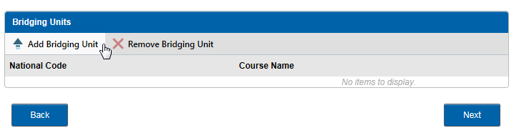

Figure 23 - Screenshot of Skills and Employment Portal - Bridging Units

Enter the Bridging Name/Code or click ‘**Search**’ to retrieve all units. Select which units are to be attached.

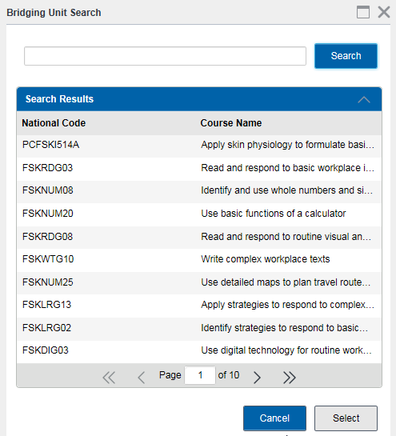

Figure 24 - Screenshot of Skills and Employment Portal - Bridging Unit Search

Once units have been attached, all added units will be shown in the right column. If a unit has been added incorrectly, highlight the unit and select ‘**Remove Bridging Unit**’. Once all bridging units are attached select ‘**Next**’ to continue or leave blank if not applicable.

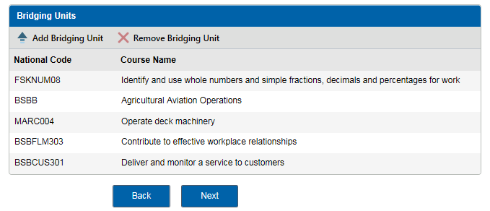

Figure 25 - Screenshot of Skills and Employment Portal - Bridging Units

**Note:** Units are to be added individually. Bridging units may be added at any time while the Training Account is active, using the ‘**Edit Training Account**’ function. The Unit must be added to the Training Account prior to the training commencement date of the Unit of Competency. Bridging units cannot be removed from a Training Account once a subsidy has been paid. Bridging Units are not eligible for school-based students, unless previously approved.

## Course Fees and Training Information

### Course Fees

The ‘Estimated Course Fee this Participant will be charged, after any concessions’ field refers to the total course fee that you estimate the participant will be charged, after any concession reimbursements.

**Note:** This is NOT your Fee for Service Fee. This is an estimated course fee payable by the Participant, taking into account bridging units, electives, Recognised Prior Learning (RPL) or Credit Transfer (CT). If the Participant is eligible for concession, this should not include the concession reimbursement that you expect to receive. Refer to the [Training Fee Framework](https://providers.skills.sa.gov.au/Deliver/Training-Fee-Framework) for information on how a concession reimbursement is calculated.

The ‘Estimated Course Hours for this Participant’ refers to the estimated hours you will deliver, taking into account bridging units, electives, RPL or CT.

### Training Information

Enter the ‘**Training Commencement Date**’ and the ‘Training Expected to Finish Date’. Note that these two dates are mandatory but editable.

Enter the ‘**Responsible delivery workgroup**’. Leave ‘**blank**’ if not applicable.

Enter the ‘**Suburb**’ and ‘**Postcode**’ of the delivery location. **Note**: These fields are mandatory as the subsidy is calculated based on delivery location. Where training delivery may take place in a variety of locations, enter the predominant delivery location.

Select if the Participant is going to be provided a ‘**Learner Case Management**’;

Select if the Participant has applied for ‘**VET Fee Help**’.

Select ‘**Next**’ to continue.

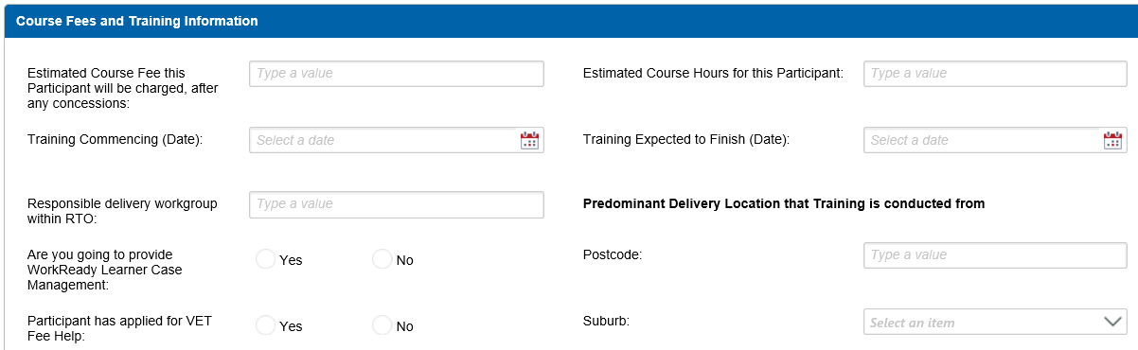

Figure 26 - Screenshot of Skills and Employment Portal - Course Fees and Training Information

## Complete the Creation of a Training Account

Review the ‘**Training Account Summary**’ screen to ensure all details entered are correct.

Confirm that the ‘**Participant has made the declaration that information provided at enrolment is to their best knowledge true and correct**’. Select ‘**Submit**’ to complete the process.

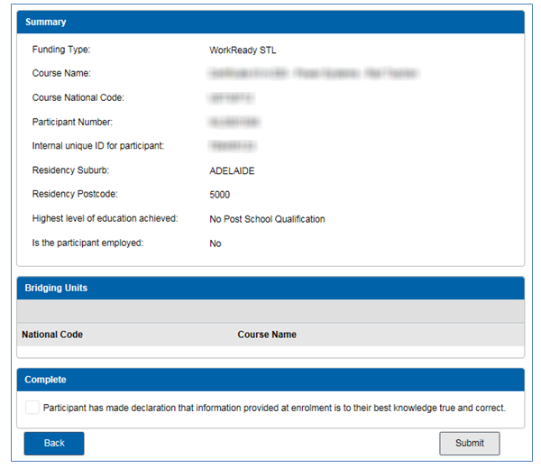

Figure 27 - Screenshot of Skills and Employment Portal - Summary and Confirmation

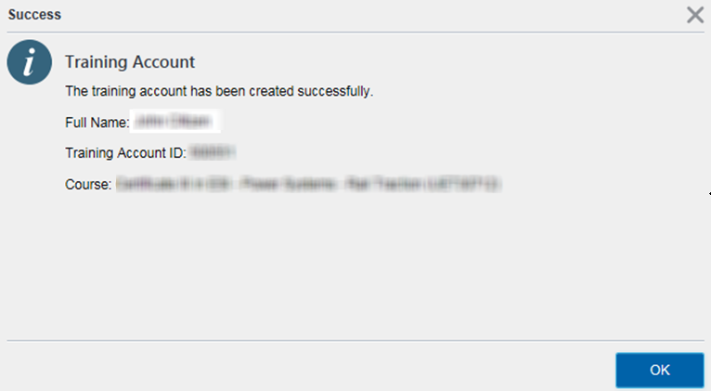

Figure 28 - Screenshot of Skills and Employment Portal - Successful Training Account creation

Congratulations - You have successfully created a Participant’s Training Account.

At this point, if the criteria for creating a Training Account has not been met, an error message will appear and you will have the opportunity to go ‘**Back**’ through the screens to review and amend. If you require any assistance when receiving an error message, please contact the Contract Administration team.

# Training Account Search

Training Account Search can be done by the Menu Bar. Select ‘**Training Account**’, then ‘**Training Account Search**’ from the sub menu, as shown below:



Figure 29 - Screenshot of Skills and Employment Portal - Training Account menu

To search for a Training Account, you may input one or any of the following details, until a match is found, e.g.:

* The full First Name and Last Name;
* Internal unique ID (this should be known by the RTO);
* Participant Number;
* Course Code;
* Course Name.

Alternatively, you can retrieve a list of all Training Accounts for your organisation by selecting ‘**Search**’.

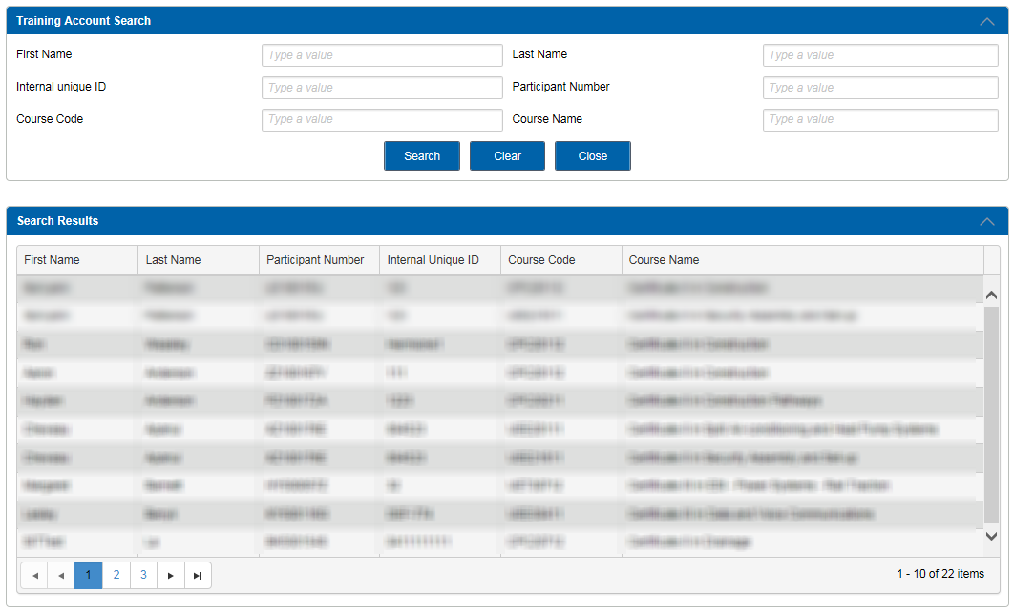

Figure 30 - Screenshot of Skills and Employment Portal - Training Account Search

A Participant may have multiple Training Accounts. Select ‘**View**’ or ‘**Edit**’ for full details of a Training Account. Note: Creation of a Training Account can not be done from this section of the Portal. Instead, this needs to be done via the Participant Search menu, see **Section 7** above for details.

Select ‘**Edit**’ to update information in editable fields for that Training Account - see **Section 9 - Appendix 1**.

# Appendix 1 - Editable Training Account Fields

The following fields are able to be edited once a Training Account is created and remains Active:

* Commonwealth Government Concession Card type and Expiry Date
* Estimated Course Fee this Participant will be charged, after any concessions
* Estimated Course Hours for this participant
* Training Commencing and Expected to Finish Dates
* Internal unique ID
* Workgroup
* Additional support
* Applied for VET FEE Help
* Delivery Suburb
* Delivery Postcode
* Leave from Enrolment Start and End Dates

# Support and Assistance

If you experience trouble creating a Participant Profile or Training Account or require any assistance with using the Skills & Employment Portal, please do not hesitate to contact the Contract Administration team.

Your feedback and comments are welcome so that we can continuously improve the Portal to meet the needs of our clients.

Telephone: 1800 673 097 and ask for the Contract Administration team

Email:  [DIS.skillscontracts@sa.gov.au](mailto:%09DIS.skillscontracts@sa.gov.au)