**Skills & Employment Portal**

User Guide: Login Procedures

Version 2.3 – Release date: August 2019

|  |  |  |  |
| --- | --- | --- | --- |
| Version | Date | Status | Comments |
| 2.3 | August 2019 | Reviewed & updated | Update DIS and Skills & Employment Portal |

**Contents**

1. Purpose 3

2. System Login 3

3. Amend Personal Details 5

4. Forgotten your Password 6

5. Support and Assistance 7

# Purpose

The Skills & Employment Portal (**Portal**) is an Information Management Portal that provides access to a number of functions – Participant Profile, Training Account, Claims and Projects (where applicable). This User Guide provides you with instructions on how to successfully login to the **Portal**, change your password and amend your personal details.

To gain access to the **Portal**, each user requires their own login. It is a breach of the ‘[**Portal User Agreement**](https://portal.statedevelopment.sa.gov.au/WorkReady/polices_forms2)’ for a user to disclose their login details to another individual.

# System Login

The Skills & Employment Portal is held in a secure environment. Once your request to access the Portal has been approved, you will be provided with a username and password to log in the system.

On receipt of your username and password, use the following steps to access:

1. Open Internet Explorer. Please note that **Internet Explorer** is the preferred internet platform for using the Portal. Also note that the Portal is not compatible with Apple Macintosh computers.
2. Type the following web address <https://portal.statedevelopment.sa.gov.au/workready> and then press the Enter key.
3. The Portal Login Screen will appear as displayed below:

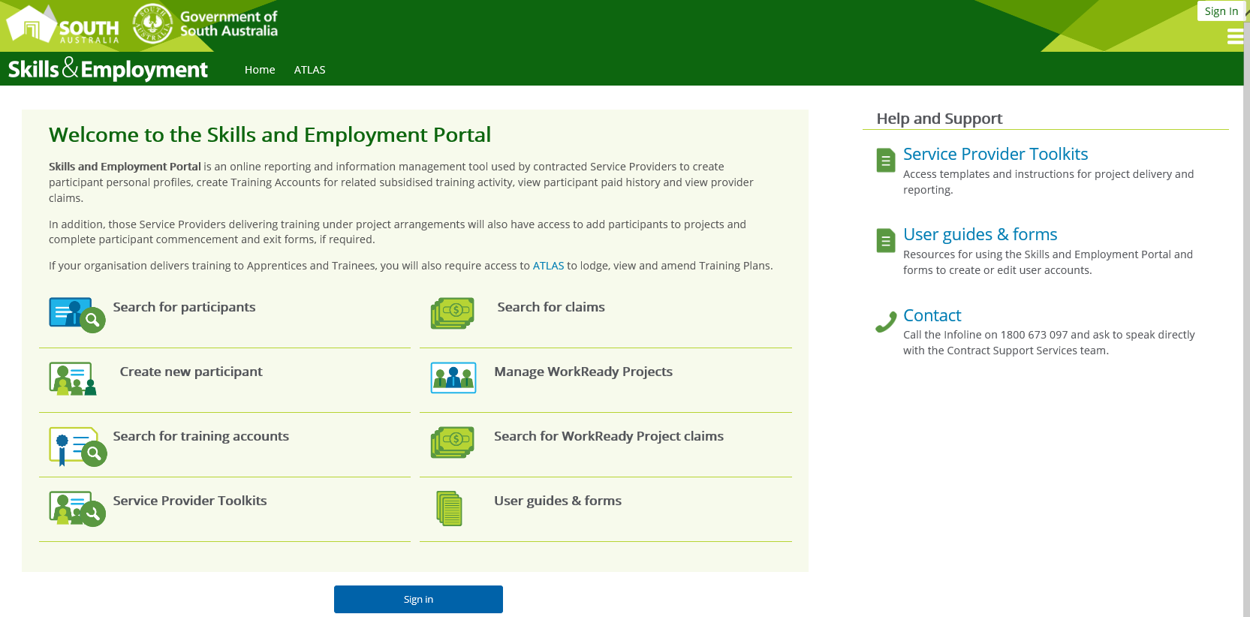

Figure 1 - Screenshot of Skills and Employment Portal Homepage

1. Select one of the two ‘**Sign In**’ buttons (on top-right or the blue ‘Sign In’ button mid screen (by scrolling down to the bottom of the page).
2. Enter your Portal username which is your email address in the Username field and enter your Portal Password, select ‘**Sign In**’.

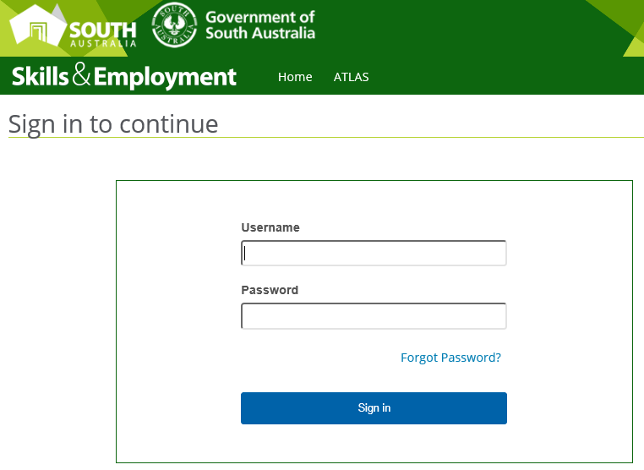

Figure 2 - Screenshot of Skills and Employment Portal - Login Screen

1. You will now be logged in to the **Portal**.

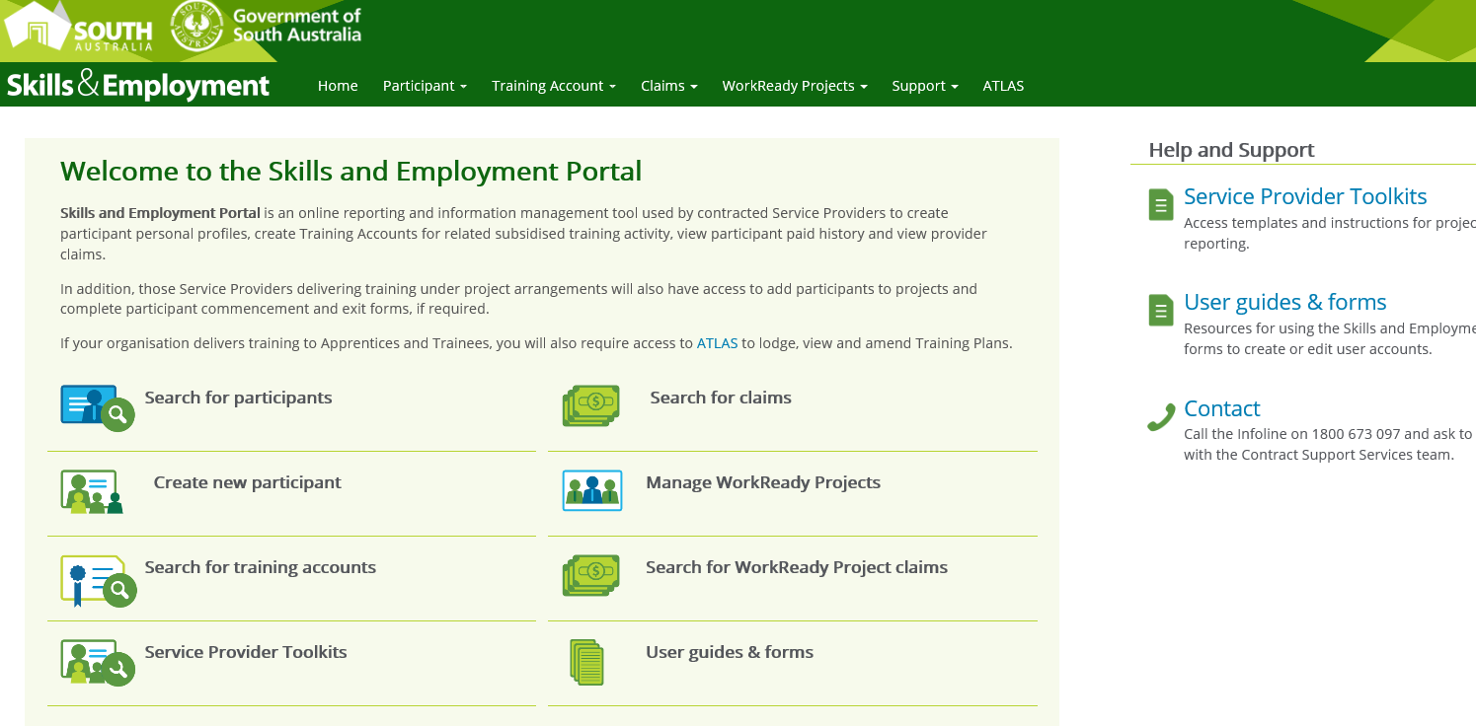

Figure 3 - Screenshot of Skills and Employment Portal – Homepage

1. You should change your password to ensure that unauthorised people are unable to access your account.
   1. Select your Username in the top right-hand corner of the screen, select ‘**Change Password**’
   2. Enter your current Password
   3. Enter a new Password
   4. Confirm the new Password
   5. Select ‘**Change Password**’ to finalise the process.

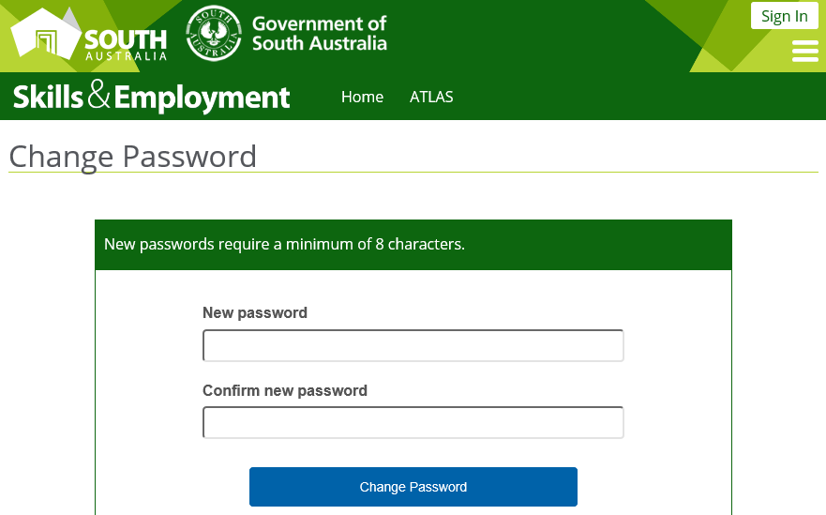

Figure 4 - Screenshot of Skills and Employment Portal - Change Password screen

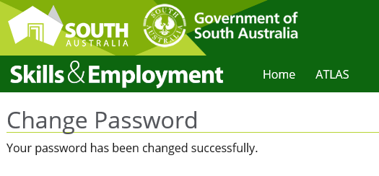

Figure 5 - Screenshot of Skills and Employment Portal - Change Password Successful

# Amend Personal Details

You can amend your registered personal details against your Portal username. However, your username is your email address, so if you change your email address, you will need to de-activate your account and establish a new username for Portal access. If you change organisation, you will be required to de-activate your account and establish a new username for the Portal access. (For these changes, please submit a new User Maintenance Form.)

To amend your personal details:

1. Select ‘**User Details**’ from the ‘**Support**’ Menu:

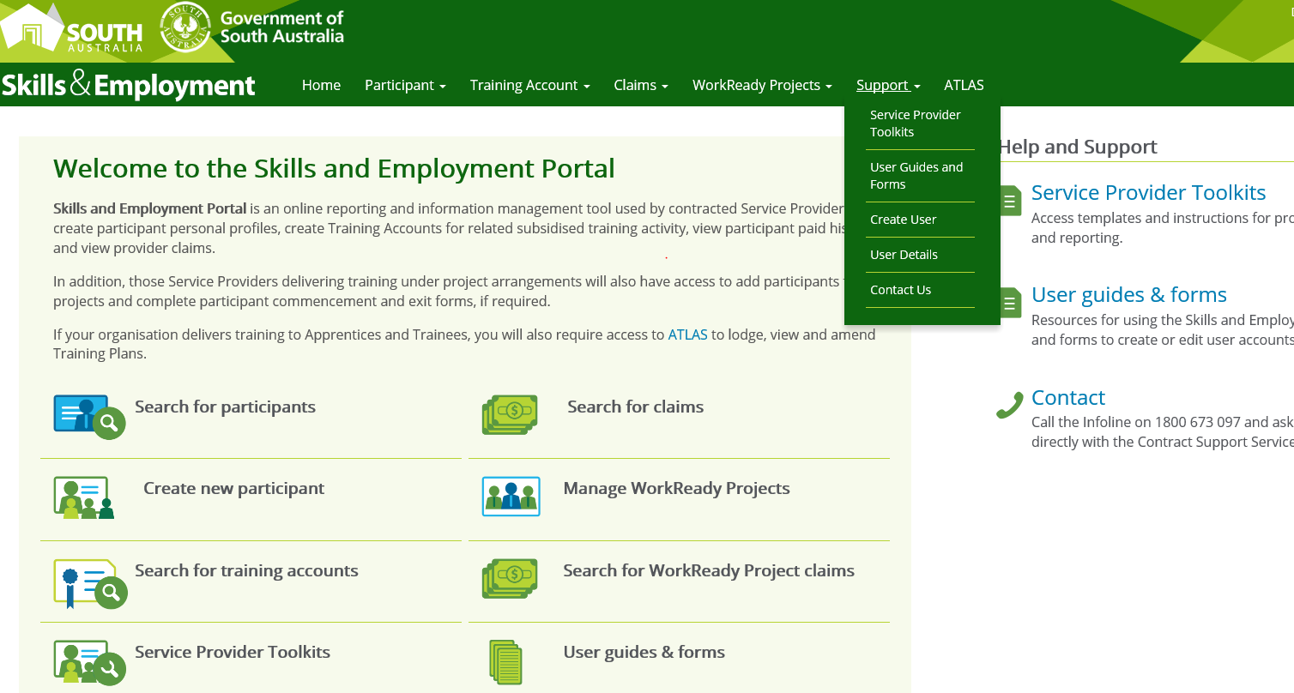

Figure 6 - Screenshot of Skills and Employment Portal - Change User Details menu

1. You are able to amend any details highlighted with a Red *

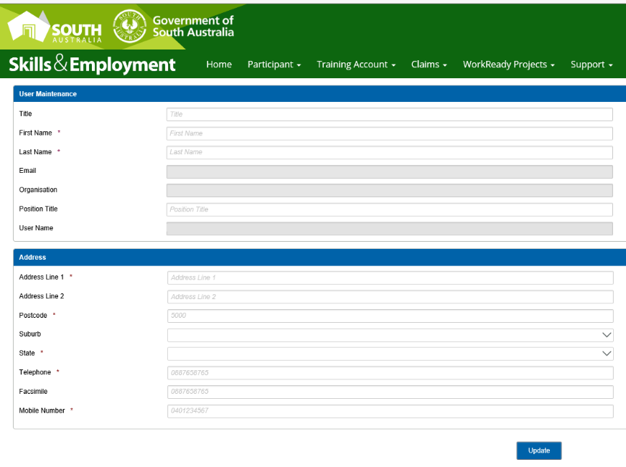

Figure 7 - Screenshot of Skills and Employment Portal - Change User Details

# Forgotten your Password

1. If you have forgotten your password, select ‘**Forgot Password?**’.

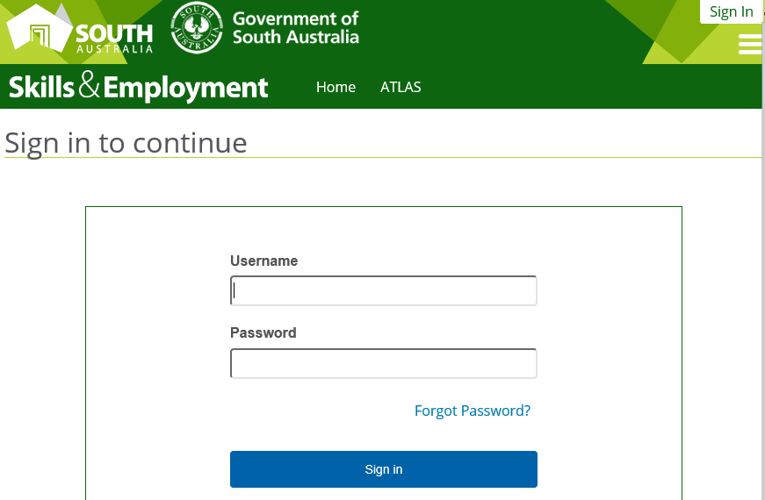

Figure 8 - Screenshot of Skills and Employment Portal - Forgot Password

1. You will be required to enter your email address, then select ‘**Send Request**’.

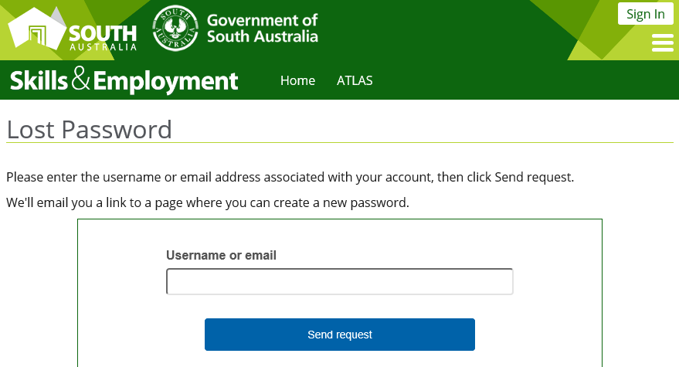

Figure 9 - Screenshot of Skills and Employment Portal - Lost Password

1. An email will be forwarded to you with a confirmation link for you to change your password. Select the link.

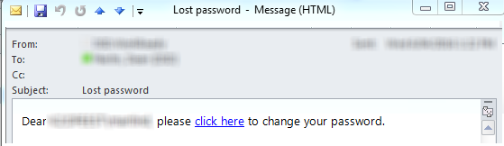

1. The selected link will take you to the Portal ‘**Change Password**’ Page. Enter a new password and confirm new password in the fields provided. Select ‘**Change Password**’ to complete the process:



Figure 10 - Screenshot of Skills and Employment Portal - Change Password

1. Once you have completed Changing your Password, you will see the below screen.

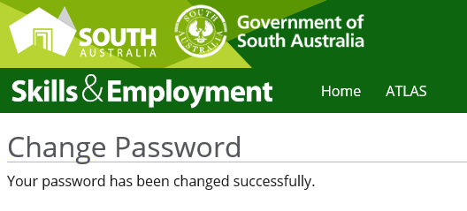

Figure 11 - Screenshot of Skills and Employment Portal - Change Password Successfully

# Support and Assistance

If you experience trouble logging into or require any assistance with using the Skills & Employment Portal, please do not hesitate to contact the Contract Support Services team.

Your feedback and comments are welcome so that we can continuously improve the Portal to meet the needs of our clients.

Telephone: 8429 2941

Email: [DIS.skillscontracts@sa.gov.au](mailto:DIS.skillscontracts@sa.gov.au)