Skilling South Australia Projects Skills & Employment Portal Reporting Instructions

Version | Release | Status | Comments
3.1 | August 2022 | Final | Routine Update

For further information or assistance in using the Skills & Employment Portal, please contact the Infoline on 1800 673 097 and ask to speak with the Contract Administration team.

Purpose
The Skills and Employment Portal (Portal) is an online system used by contracted Recipients and nominated Registered Training Organisations (RTOs). This document explains the use of Portal by Recipients delivering a Skilling South Australia (SSA) Project through a Funded Activities Agreement (FAA), and its Funded Activities Annexure - Attachment 4 (Annexure).
RTOs delivering Accredited Training through a FAA – STL Qualifications will continue to use the Portal to create Training Accounts, and view claims and payments.
Your SSA Project may have specific reporting requirements to trigger milestone payments which are not covered in this document. As a contracted Recipient and nominated RTO (if applicable), it is crucial that you understand your contractual obligations and read your FAA thoroughly.
This document should be read in conjunction with:
- Your Annexure for a specific project;
- Fact Sheet – Skilling South Australia Projects – Contract Overview; and
- Various User Guides on How to log into the Portal, How to create Participant Profile and Training Account; Maintaining and closing Training Accounts; and Data collection, View Claims and Payment (for Accredited Training).
The Portal is used for various DIS programs and initiatives; only the ‘Projects’ section on the Portal (see Figure 4) referred to in this document is applicable for Recipients delivering a Project under SSA Projects.

Reporting process
The Portal is the primary reporting tool for Projects administered through an Annexure (SSA Project). Use of the Portal for reporting is shown in the below flowchart (Figure 1), and an overview of information to be reported is detailed below. Step-by-Step instructions for using the Portal are from section 3 - System login onwards.

Participant information
To participate in a Project, all Participants must first fill in and sign the Skilling South Australia Projects – Participant Agreement. This form identifies the participant and provides authorisation for the Department to collect and use Participant information. Recipients are not required to email a copy of the completed Participant Agreement to the Department however the signed form must be retained as required under the FAA.
Once the Participant Agreement has been completed, the Recipient must use the Portal to:
- Search for an existing Participant Profile. If a Profile does not exist for a Participant, the Recipient must create one.
- Add the Participant to the Project. Within 15 days of a participant completing the Participant Agreement form, the Recipient must enter the Participant details into the Portal and add the Participant to the Project Record within the Portal.

Accredited Training
If Accredited Training is part of your SSA Project (either a skill cluster or a full qualification, or both), a Training Account for each Participant must be created in the Portal against the Funding Program specified in your Annexure, prior to delivery of any subsidised training.
Accredited Training must be delivered and reported by the RTO nominated in the relevant Annexure. RTOs delivering Accredited Training for a Project will be issued an Annexure relating to the approved SSA Project. The Annexure will specify the correct Fund Source Indicator (FSI) and Contract/Project ID for the RTO to report training against in STELA.
If an RTO is delivering training for multiple Projects, an Annexure will be issued for each Project. RTOs must create Training Accounts for each participant undertaking training prior to commencing delivery of any training. Any training commenced prior to the Training Account creation is not eligible for payment.
If training under the Project is delivered by an RTO without a FAA, the Recipient must seek approval for subcontracting to that RTO. Prior to the commencement of Accredited Training, a written agreement must be executed with the approved sub-contractor and made available on request by the Minister. The Recipient must pass down any relevant reporting requirements to their RTO for reporting Accredited Training in STELA. This usually involves a specific FSI and a Contract/Project ID which will be specified in the Recipient’s Annexure (SSA Project).
Successful generation of a claim for Accredited Training payment depends on:
- complete and accurate data in the Training Account for each eligible participant on the Portal;
- compliant, accurate and complete AVETMISS data submission in STELA; and
- accurate matching of reported data elements against Training Accounts for each participant.

Training Account Creation
Training Accounts can only be created for Participants after the Recipient has added the Participant to their Project in the Portal. A ‘Participant Number’ will be generated when the Participant Profile is created (or already available if there is an existing Participant Profile).
The correct Participant Number must then be used by the nominated RTO to create a Training Account. Where the Recipient is not the same organisation as the nominated RTO, the Recipient must give the RTO the correct ‘Participant Number’ after the Participant Profile has been added to the Project in Portal.
It is the Recipient’s responsibility to notify the RTO when Participants have been added to a Project and provide the RTO with the correct ‘Participant Number’.
The RTO must ensure that a Training Account is created prior to delivery of any training. Units commenced prior to the Training Account creation date are not eligible for payment.
* Note that prior to creation of a Training Account, a student record must be created in the RTO’s Student Management System (an external system or STELA) to obtain the ‘RTO student ID’, a field required for TA creation.

AVETMISS data submission
AVETMISS compliant data containing payable fund sources are to be submitted to STELA by RTOs for payment purposes. AVETMISS data is used to match with Training Account data in the Portal and calculate training subsidies for Accredited Training (where applicable). Data accuracy is critical to enable a successful claim and payment process.
Refer to the STELA NAT Upload User Guide for detailed instructions on how to use STELA.

Reporting Process – Flowchart
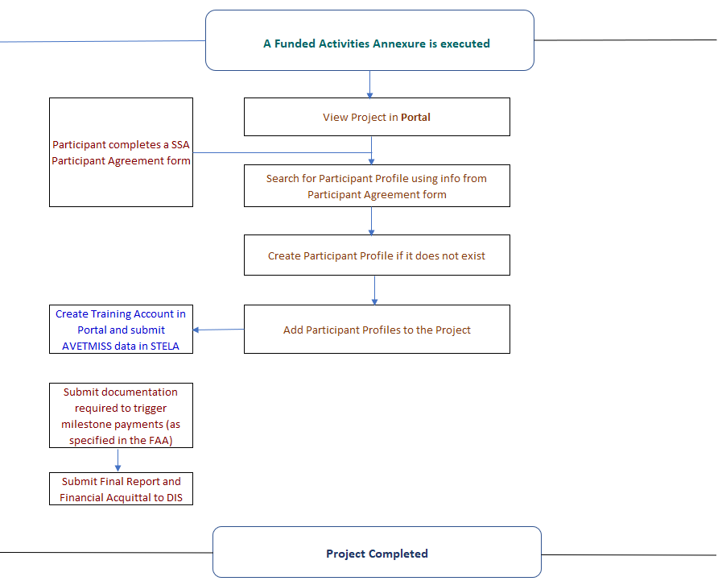
Figure 1. Skilling South Australia Project - Reporting Process Flowchart

System login
The Portal operates in a secure environment; you will need a username and password to login to Portal, and permission to access content under Projects. If you do not have a Login and/or relevant access, please refer to the Supporting Skilled careers website for Skills & Employment Portal Login Request.

How to log in
On receipt of your username and password use the following steps to access the Portal:
Open your web browser and type in https://portal.statedevelopment.sa.gov.au/workready. The Portal homepage will display. Select the ‘Sign in’ button in the top right-hand corner. The Skills & Employment Portal sign in screen will display for you to enter Username and Password.
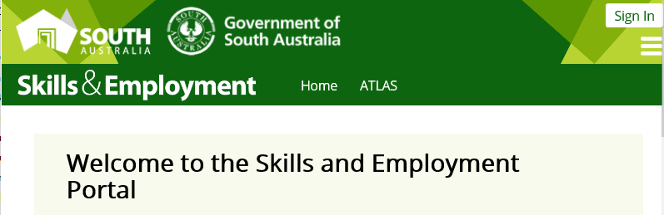
Figure 2 - Screenshot of the Portal homepage

Search and view a Project
The Portal will display Projects for the organisation identified in your request to access the Portal. From the Portal Menu Bar select ‘Projects’ from the sub menu.
Figure 3. Screenshot of menu options for Projects
All current and expired Projects delivered by your organisation will be listed.
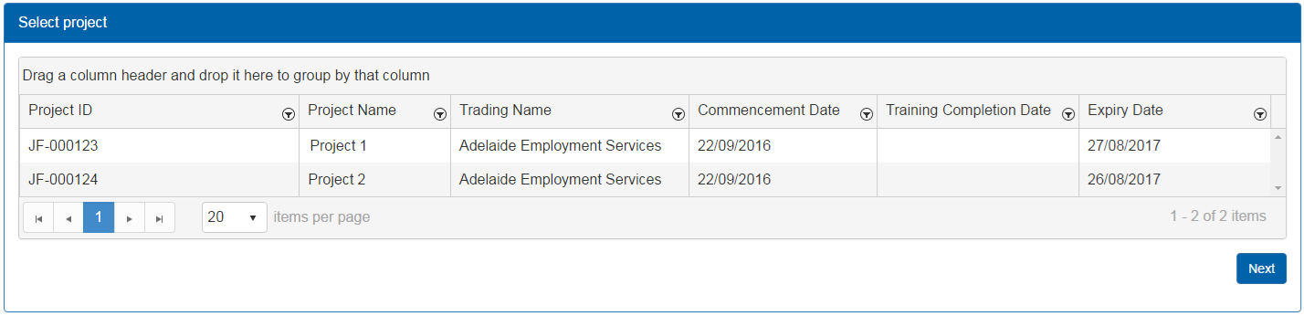
Figure 4. Screenshot of Projects listed for an organisation
If multiple Projects are displayed or there is more than one page, filter the results by column. Simply click on the filter icon ( ) in the relevant column and enter the values you wish to search.
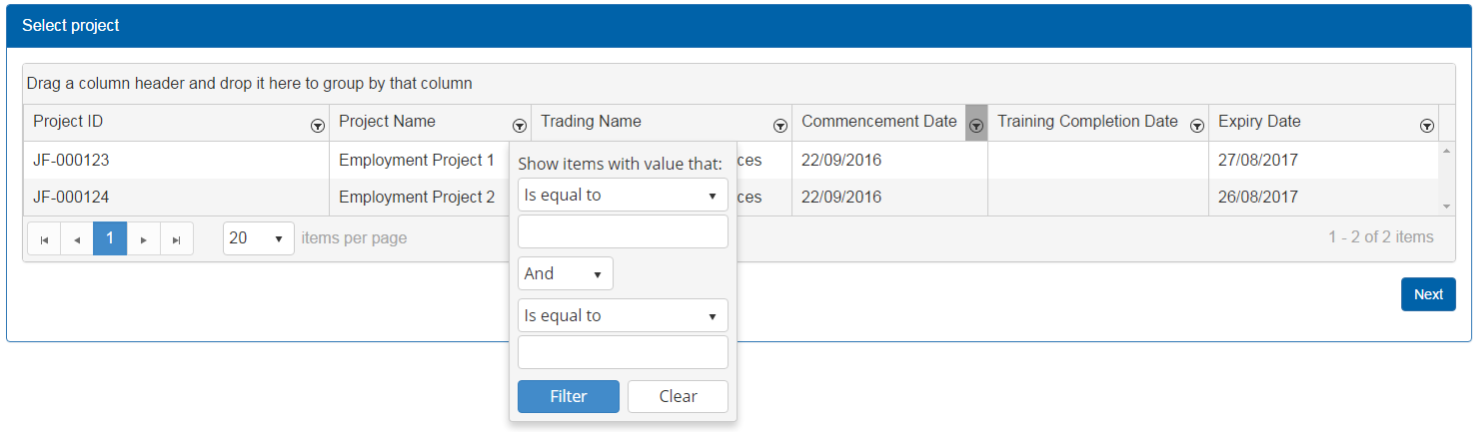
Figure 5. Screenshot of filtering results from Project list, by Project name
If you have a filter applied to a column, this will be indicated by a grey highlight ( ).
When you have located the Project, you can view, double-click or select the Project to highlight the line and click ‘Next’.
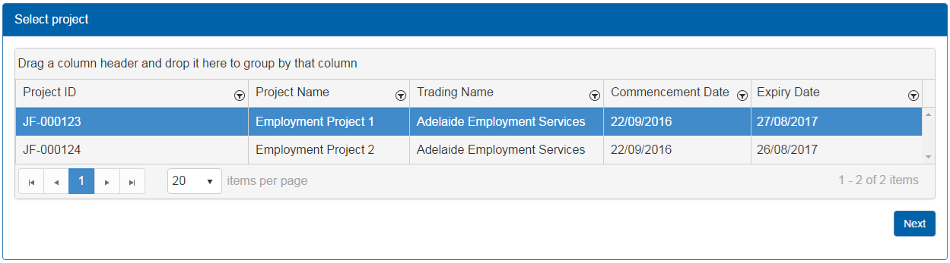
Figure 6. Screenshot of selecting a Project and location of ‘Next’ button
You will be taken to the landing page for the Project, which will display:
- Project ID
- Participants who have been added to the Project, with the ability to delete a Participant from the Project.
- Buttons to add Participants to the Project and create a Participant Profile if none already exists.

Managing Participants in a Project

Add a Participant to a Project
To add a Participant to a selected Project, find the Project and go to the Project page (see section 4 - Search and view a Project). When on the Project page, click on the ‘Add Participant’ button.
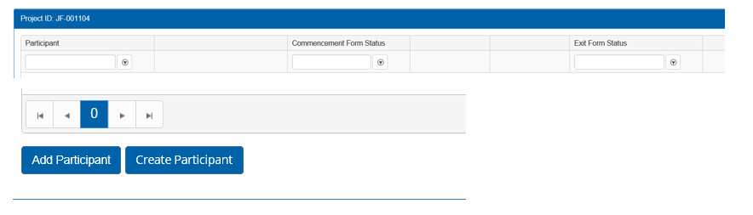
Figure 7. Location of ‘Add Participant’ button on Project landing page
The Participant Search screen will display:
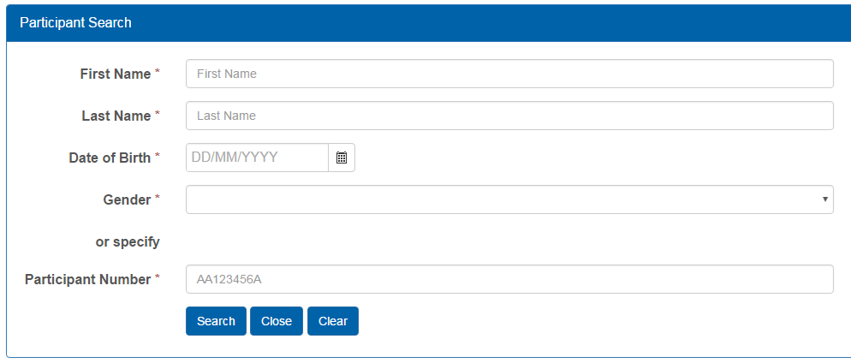
Figure 8. Screenshot of Participant Search screen
Search existing Participant Profiles in the Portal by entering:
- first name AND last name AND date of birth AND gender OR
- a Participant Number – this is a unique number generated by the Portal and is only allocated once.
- If the Portal is unable to retrieve matching data, a message will display stating that no Participant Profile could be found. You will need to create a new Participant Profile – see section 5.1.1. Create a Participant Profile.

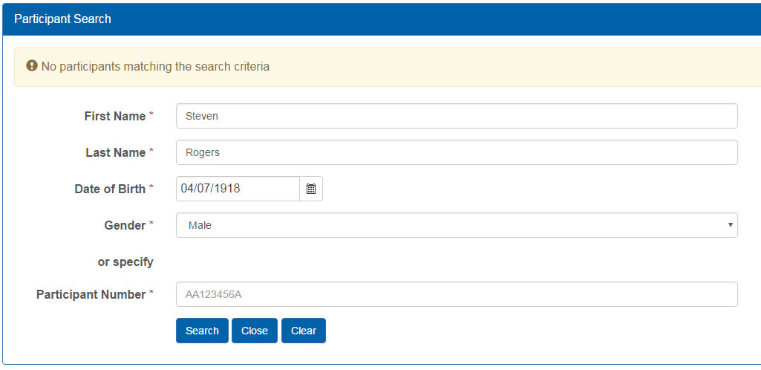
Figure 9. Screenshot of ‘No participants matching the search criteria’ result
- If there is a match, the Participant Profile will appear as displayed below. If more than one Participant Profile is found, Portal will prompt for more information about the Participant in order to match with other fields in the Participant Profile.
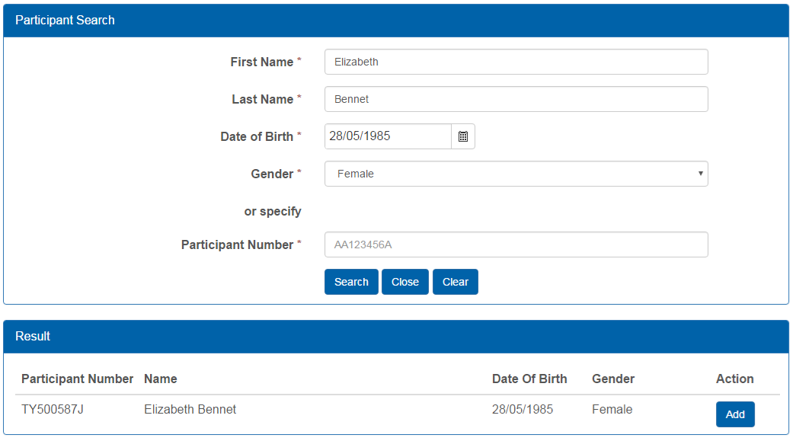
Figure 10. Screenshot of successful Participant search
When you have located the Participant that you wish to add to the Project, select ‘Add’ (as per Figure 10). You will then be returned to the Project landing page and the Participant you added will be listed.
When a Participant has been added to a Project, you will be able to provide the Participant ID to your RTO, so that Training Accounts can be created to enable the RTO to make claims for Accredited Training.
If a participant has been added to a project in error and no Training Account has been created for under the Project, you may delete the participant from your Project.

Create a Participant Profile
Participant Profiles should only be created if one does not already exist for that participant. Before creating a profile, you must first search Portal to check if a Profile already exists, to avoid the creation of duplicate records.
To create a Participant Profile, go to the Project page and click on the ‘Create Participant’ button.
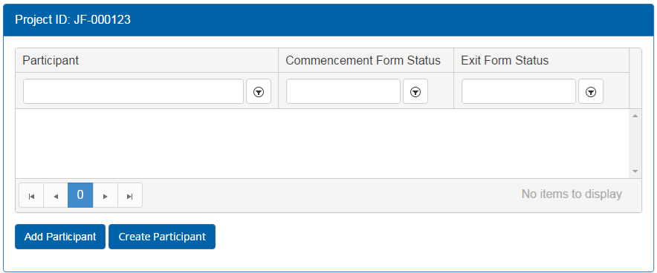
Figure 11. Location of ‘Create Participant’ button on Project landing page
This will take you to a new screen where you can create a new Participant record.
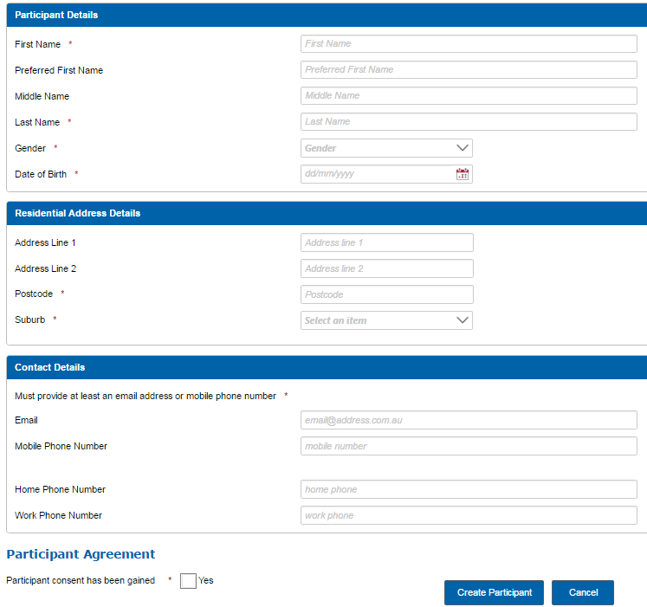
Figure 12. Screenshot of New Participant Profile screen
The headings in this form as follows:
- Participant Details
- Residential Address Details
- Contact Details
- Participant Agreement.
Refer to Tables 1 through 4 on next pages about the information to be entered into the Portal. Mandatory fields are indicated by an asterisk (*). Please check information entered for accuracy before completing the Participant Profile and ensure information is consistent with any training reported in STELA for that participant by the nominated RTO (if applicable).
Table 1. New Participant Record - description of fields in Participant Details
Field | Format | Additional Information
First Name *  Last Name * | Free text | This field is mandatory. Use capitals for first letter of each name, unless this is not a required in the spelling of the name.
Preferred First Name | Free text | Use capitals for first letter of each name, unless this is not a required in the spelling of the name.
Middle Name | Free text | Used to search if there is more than one match in the Participant Profile.  Use capitals for first letter of each name, unless this is not a required in the spelling of the name.
Gender * | Drop down selection | This field is mandatory. Options are:  - Male  - Female  - Not specified
Date of birth * | Number only | This field is mandatory. Date format – dd/mm/yyyy
Table 2. New Participant Record – description of fields in Residential Address Details
Field | Format | Additional Information
Address Line 1 | Free Text | Spell out Unit, Road, Street, Avenue etc.
Address Line 2 | Free Text | Spell out Unit, Road, Street, Avenue etc.
Postcode * | Number only | This field is mandatory. Example: 5000
Suburb * | Drop down selection | This field is mandatory. Suburb options will display upon entry of a valid postcode. Select the appropriate suburb name.
Table 3. New Participant Record – description of fields in Contact Details
Field | Format | Additional Information
Email * | Free Text | Must provide at least an email address or mobile phone number.  Example: email@address.com.au
Mobile Phone Number * | Number only | Must provide at least an email address or mobile phone number.  Please do not use spaces. Example: 0444144144
Home / Work Phone Number | Number only | Please do not use spaces. Example: 0818881888
Table 4. New Participant Record – description of field in Participant Agreement
Field | Format | Additional Information
Participant consent has been gained * | Check box | This field is mandatory. Ticking this box is an indication that the Participant has completed and signed a consent form for collection and use of their personal information.  For all Projects, this is contained in the SSA Participant Agreement Form.
When the information has been entered, select ‘Create Participant’. The system will validate data entered and verify the details against existing Participant Profiles.
- If no duplicate Participant Profile exists, the following message will display to indicate that the new Participant Profile has been created. Click ‘Close’; this will return you to the Portal landing page.
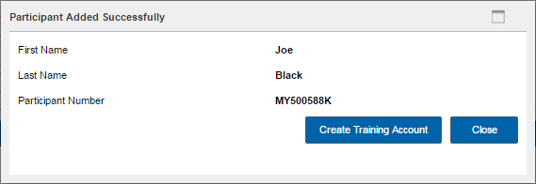
Figure 13. Screenshot of new Participant profile message
- If a Participant exists with the same First Name, Last Name, Date of Birth and Gender, the Participant won’t be duplicated. Instead, the system will provide the Participant Number relating to the existing profile.
To add the Participant to a Project, follow the process outlined in section 5.1 - Add a Participant to a Project.
Once a Participant has been successfully added to the Project, they will appear in the Project view screen. Please note that ‘Commencement Form’, ‘Submit Claim’ and ‘Exit Form’ buttons do not need to be used as these forms are not required for Skilling South Australia Projects, unless specified in your FAA Annexure.
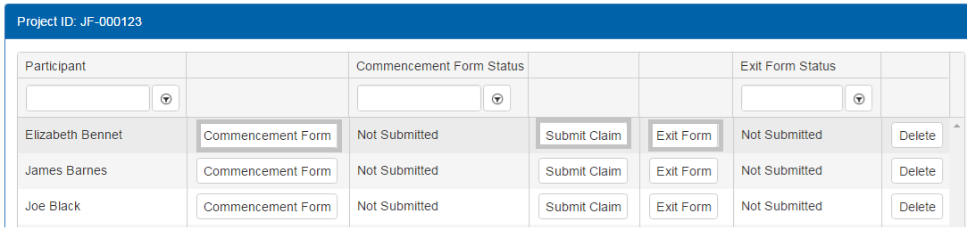
Figure 14. Screenshot of buttons not required for Skilling South Australia Projects

Delete a Participant from a Project
You can only delete a Participant from a Project if a Training Account not yet been created by the nominated RTO for the Participant under the Project. To delete a Participant, go to the Participant list for the relevant Project. When on the Project page, identify the Participant you wish to remove from the Project and select ‘Delete’.
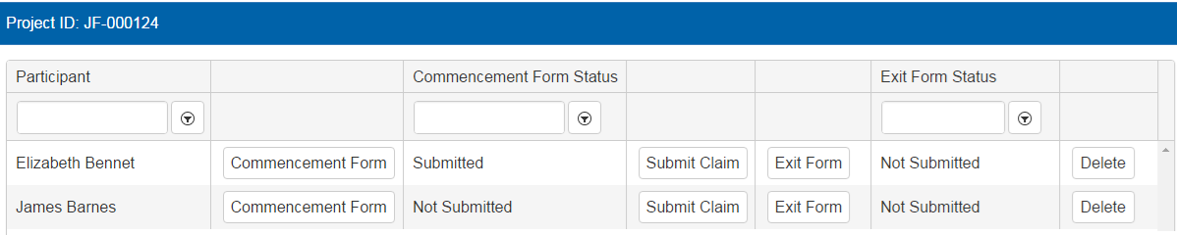
Figure 15 - Screenshot of selecting Delete for a Participant
If a Training Account has not been established for that Participant under the Project, the Participant record will be removed from the Project and they will no longer display on the Participant list.

